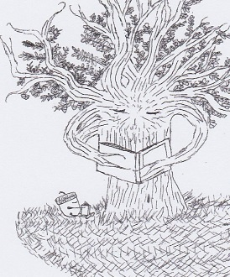
Friends of the J. Joel Edwards Public Library
J. Joel Edwards Public Library
PO Box 1353
Zebulon, GA 30295

Seventh Annual A TASTE OF TWO COUNTIES
BENEFITTING FRIENDS OF THE J. JOEL EDWARDS PUBLIC LIBRARY

Platinum Sponsor ($1000) reserved tables for eighteen guests, signage, full-page bio and logo of business in the printed program (inside front page, back page or mid-section), logo in slideshow. **
Gold Sponsor ($650) reserved tables for twelve guests, signage, one-half page bio and logo of your business in the printed program, logo in slideshow. **
Silver Sponsor ($400) reserved table for six guests, signage, one-quarter page bio and logo in the printed program, logo in slideshow. **
**To be included payment must be received by February 15, 2022
Also, if you would like to receive your tax-deductible credit for this year (2021) please remit payment by December 31, 2021 and we will send you the appropriate document to use to receive your credit.
Please make check payable to:
Friends of the J. Joel Edwards Public Library (FJJEPL)
P. O. Box 1353
Zebulon, GA 30295
Questions??? Contact Bobby Bunn (770) 584-3094 or Bonnie Pfrogner (770) 228-4436
Business ___________________________________________________
Contact Name_______________________________________________
Contact Phone Number________________________________________
Contact email________________________________________________

Sponsor Level (Circle One): Platinum $1000 Gold $650 Silver $400

