Pike County, GA
Budget Guide – Fiscal Year 2026-2027


Board of Commissioners District Map




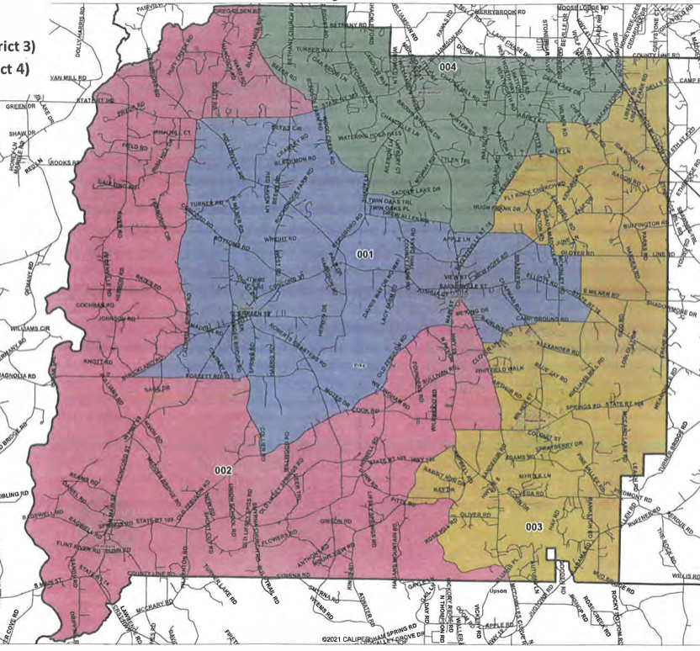
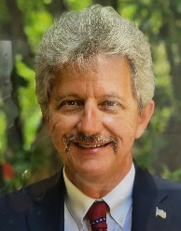

Briar Johnson Chairman



Tim Daniel
District 1



Tim Guy
District 2
James Jenkins
District 4
Ken Pullin
District 3

Table of Contents
FY 2025-26 Accomplishments ………………………………………………………………… 6
History of Pike County, Georgia ………………………………………………………………… 8
Pike County Organizational Chart ………………………………………………………………………… 9
FY 2026-27 Budget Calendar ……………………………………………………………………………. 10
FY 2026-27 Budget Resolution ………………………………………………………………………….. 11

GENERAL FUND

General Fund Revenues and Summary of Expenditures …. 16

General Fund Departmental Budgets
Animal Control . 27
Board of Commissioners/Administration . 31
Board of Elections and Registration .. 37
Board of Equalization.. 41
Building and Grounds. 43
Coroner. 47
Clerk of Superior Court 50
Court Services 53
District Attorney 56
Emergency Management Agency 58
Fire Department 61
Inmate Care 65
Jail 67
Magistrate Court 70
Planning and Development 73
Probate Court 76
Public Defender 79
Public Works 81
Senior Center 86
Sheriff's Office 89
Solid Waste 93
Table of Contents - Continued
Tax Assessor 95
Tax Commissioner 99
General Fund Transfers 102

Outside Agencies
Agribusiness Authority 103
Ambulance Contract 105
Community Services 107
County Agent (EXTENSION SERVICES) 109
Development Authority of Pike County 112
Forestry 114
Georgia Division of Family and Children Services (DFACS) 116
Health Department 118
Pike County Public Library 120
Pike County Parks and Recreation Authority 123
Pike County Water and Sewerage Authority 125

SPECIAL REVENUE FUNDS

American Rescue Plan Act Fund (ARPA) 128
Drug Abuse Treatment & Education Fund (DATE) 132
E911 Fund 135
Federal Seizure Fund 139
Hotel/Motel Tax Fund 142
Impact Fee Fund 145
Juvenile Court Fund 149
Law Library Fund 152
Opioid Abatement Fund 155
Probate Court Technology Fee Fund 158

Table of Contents - Continued
CAPITAL PROJECT FUNDS
SPLOST-2016 Fund 162
SPLOST-2022 Fund 166
LMIG Fund 170
Capital Improvement Fund 175

Long Term Debt Schedule 179

Statistical Information 183

FY 2025-26 County Accomplishments
1. Sold County Farm Road property to the Development Authority, paid off the bank note with those proceeds and maintained rights to a portion for future county development.
2. Converted to a new VOIP phone system at a significant savings to the county.
3. Completed emergency roof repairs on the courthouse annex building following major storm damage, preventing further structural deterioration and protecting county assets.
4. Disposed of outdated public works equipment through surplus sales, reducing maintenance costs and generating revenue for replacement needs.
5. Finalizing a salary study through the UGA Carl Vinson Institute of Government to assess compensation competitiveness and support informed workforce planning.
6. Received a financial statement audit with no findings for the second straight year.
7. Hired a consultant to verify all county parcels, residential and commercial, have been properly classified and reassessed within the State's prescribed time period.
8. Completed three parcel sales through the Public Facilities Authority.
9. Converted jury duty pay to a streamlined debit card system.
10. Secured a new health insurance broker through a competitive bid process.
11. Purchased a new truck and several large pieces of equipment for Public Works including a motor grader and Gradall excavator.
12. Successfully paved and closed out a CDBG grant related to Tanyard Road.
13. Resurfaced, patched or began plans toward work on portions of multiple county roads including McKinley Road, West Road, Wood Creek Road, Hunter Road, West Fossett Road, Scott Road, Ward Road, Harden Road, Friendship Circle, McCard Lake Road, Gaulding Road, Melville Brown Road, using a combination of LMIG, LRA, SPLOST and/or General Funds.
14. Completed the second flyover for a digital ariel mapping project for the county.
15. Purchased and outfitted four new Sheriff's Office patrol vehicles.
16. Installed three of four outdoor warning sirens in various locations within the county.
17. Completed the redesign and installation of a new circulation desk within the library to help better serve a growing number of library users.
18. Converted to a new county-wide fuel control system to better control costs and efficiency.
19. Completing impact fee study to update and assess strategic department plans and needs and determine where fees should be set.
20 Providing administrative services and in-kind costs to the Recreation Authority in relation to their recreation complex phase 2 D.N.R. Grant project.
21. Continued to build on the successful implementation by the Sheriff's Office of the Flock Safety camera program
FY 2025-26 County Accomplishments
22. Contracted services to rebuild and update the official county website.
23. Maintained the county's financial stability despite inflationary pressures and millage rate rollbacks in four of the last six years.
24. Completed repair and maintenance of the historic courthouse staircase.
25. Negotiated a payback plan between the county and the Agribusiness Authority for the Chestnut Oak facility.

History of Pike County, Georgia

Pike County was established on December 9, 1822, carved from Monroe County as Georgia's 57th county. It was named in honor of Zebulon Montgomery Pike, a U.S. Army officer and explorer renowned for his 1805 expedition that led to the discovery of Pikes Peak in Colorado.
The county seat, Zebulon, was designated in 1825, also bearing the name of General Pike. The first courthouse was a simple log structure, reflecting the modest beginnings of the county's administrative functions. This was later replaced by a brick courthouse in 1895, which still stands today as a historic landmark.
The county's early settlers utilized Native American trails for transportation. In the 1830s, these trails were improved with planks to support stagecoaches, leading to the creation of the Old Plank Road. Another significant route, the Old Alabama Road, connected Columbus to Augusta, traversing Pike County . ​
Throughout the 19th century, Pike County's economy was predominantly agricultural, with cotton being the primary cash crop. The arrival of the railroad in the late 1800s facilitated trade and contributed to the growth of towns within the county.
During the Civil War (1861–1865), many local men enlisted in the Confederate forces, while others remained loyal to the Union. This division led to internal conflicts that persisted even after the war. The abolition of slavery and the decline of the plantation system brought significant social and economic changes to the county.
Several towns and communities developed over time, including Concord, Meansville, Molena, Williamson, and Zebulon. Each has its unique history and contributions to the county's cultural fabric. For instance, the Bank of Molena, founded in 1899, is noted as the oldest bank in the county. Education and religious institutions played significant roles in community development. Churches and schools were established early on, serving as centers for social and educational activities.
As of the 2020 census, Pike County had a population of 18,889. While agriculture remains a part of the local economy, the county has seen diversification with residents commuting to nearby urban centers for employment. Efforts to preserve the county's rich history are evident in the maintenance of historic sites and the celebration of its bicentennial in 2022.

Organizational Chart

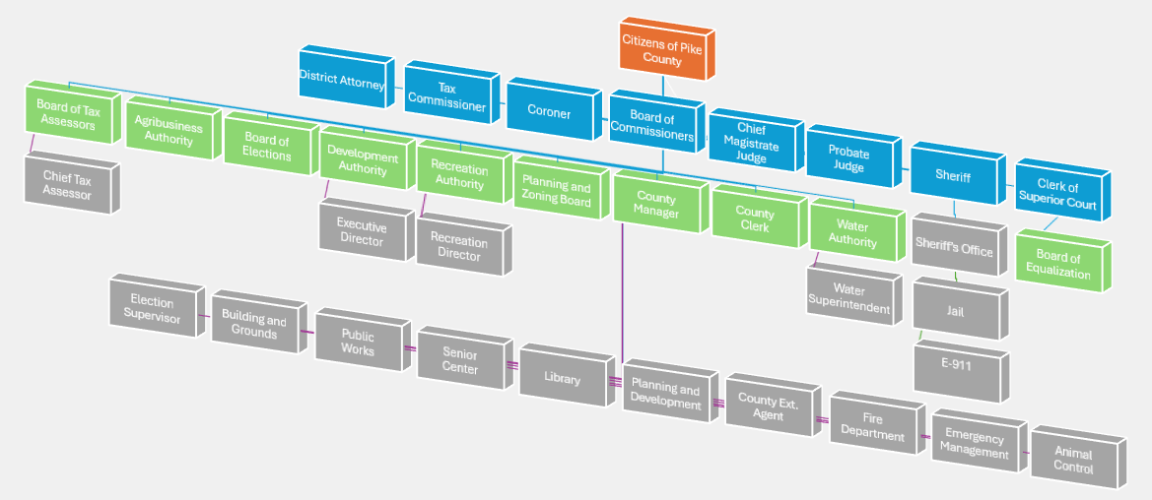

Elected Officials
Appointed Officials
Department Heads
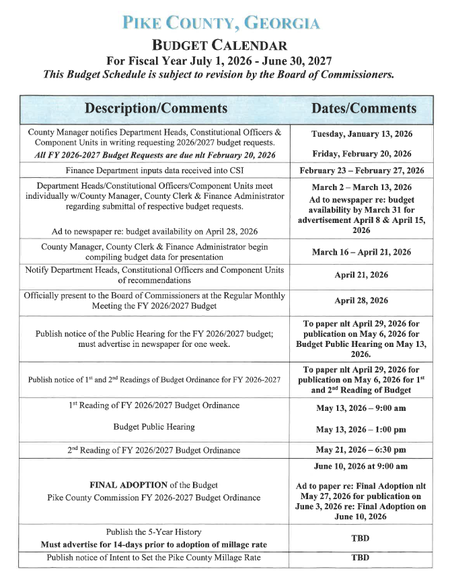
Fiscal Year 2026-2027 Budget Resolution
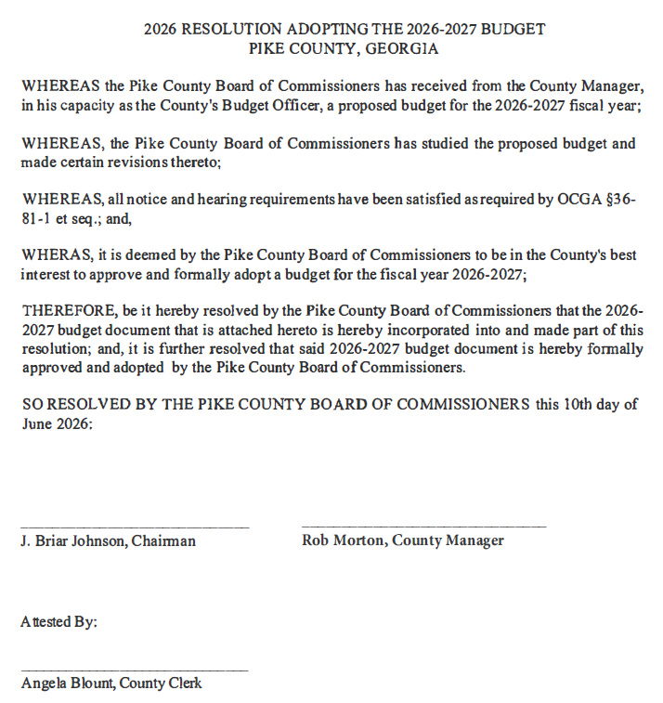

Fiscal Year 2026-2027 Budget Resolution
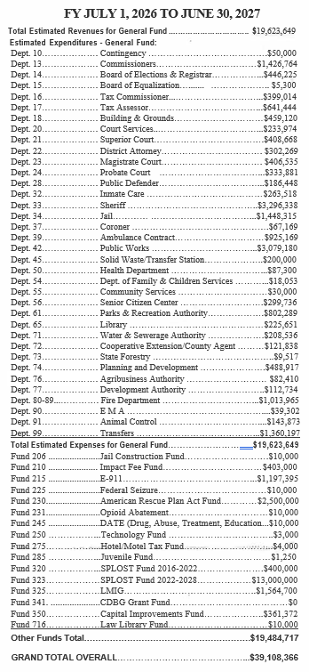

Fund Structure
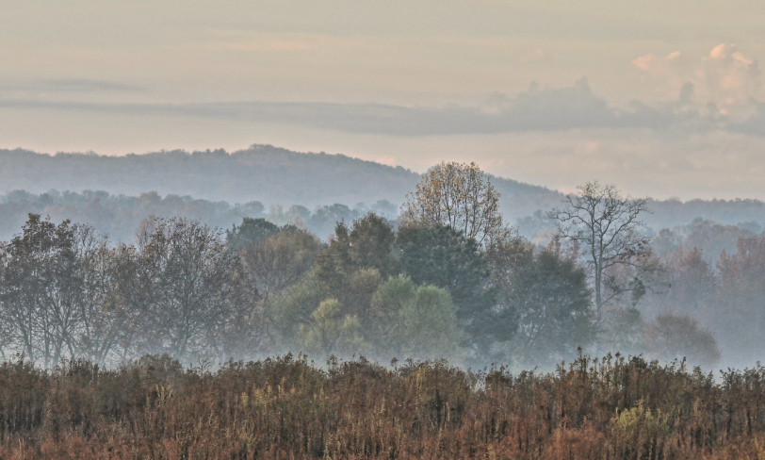

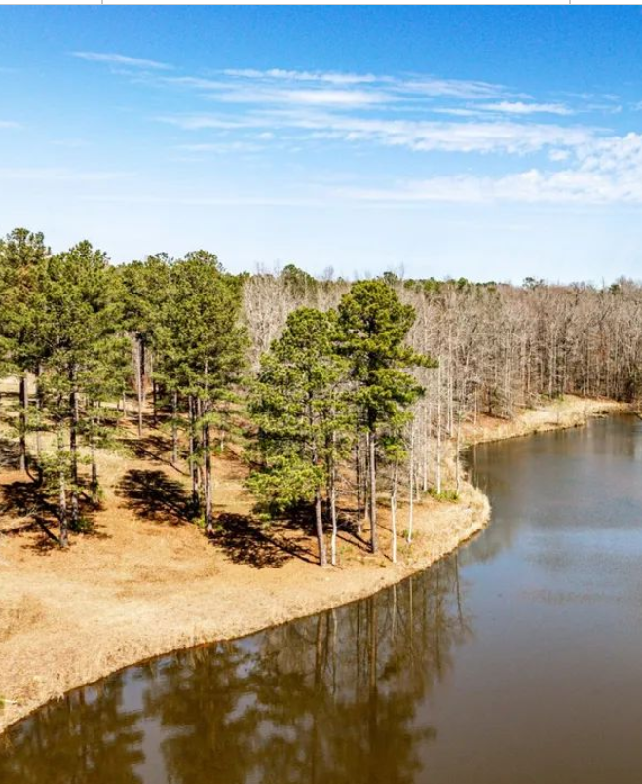
General Fund
The General Fund is used to account for all financial transactions of a general nature which are not accounted for in other funds. The General Fund is supported by revenues derived from taxes, licenses, permits, charges for services, fines, investments and other sources. Services funded by the General Fund include general government, law enforcement, court system and health and human services.


General Fund – Beginning Fund Balance Analysis

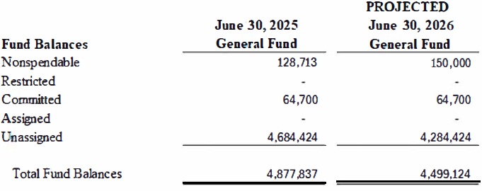

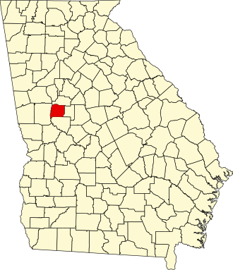

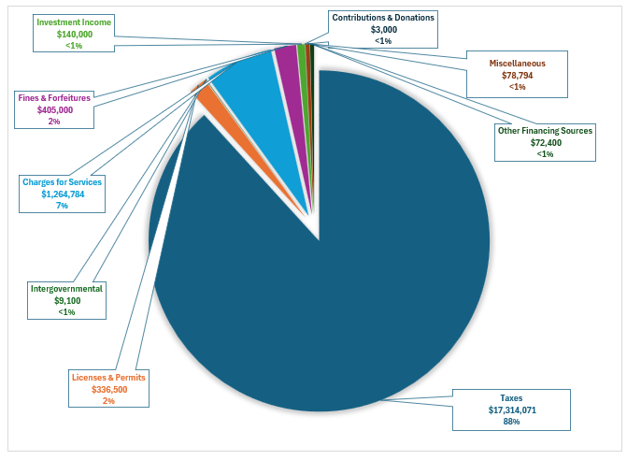
General Fund Revenues by Source

General Fund Revenues – Detail
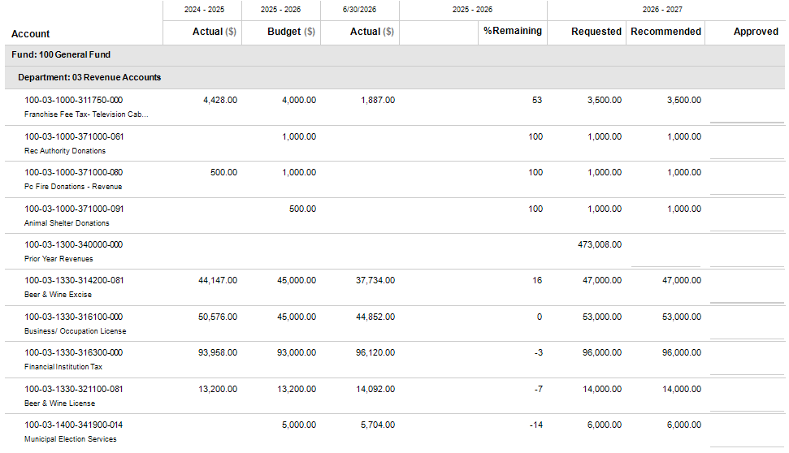

General Fund Revenues – Detail Continued
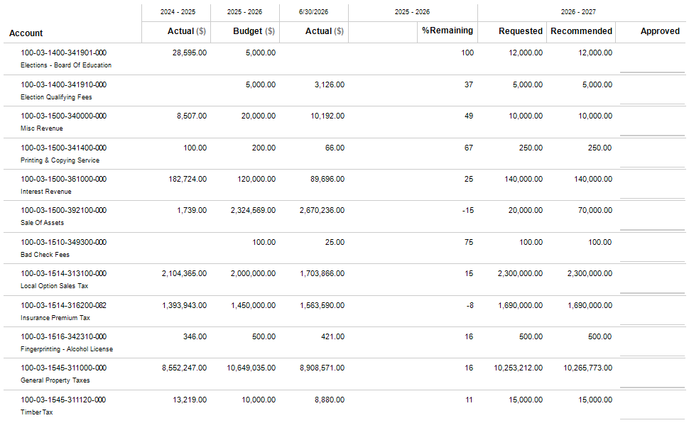
General Fund Revenues – Detail Continued
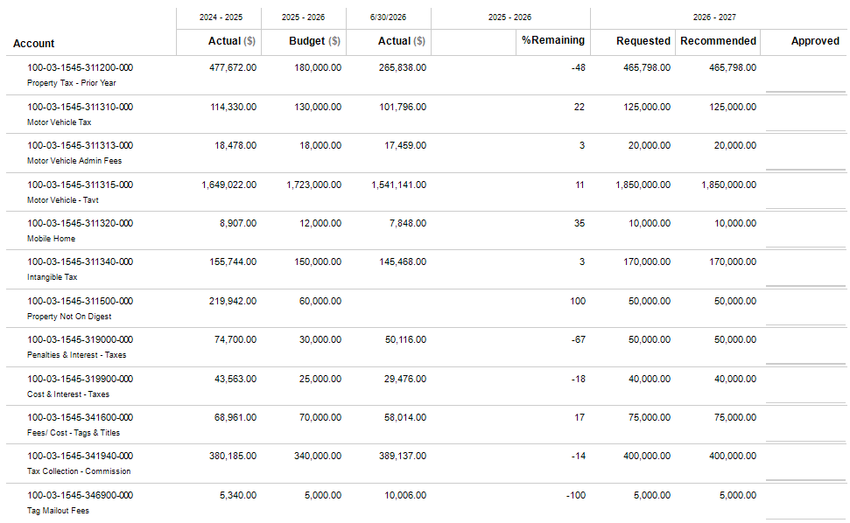
General Fund Revenues – Detail Continued
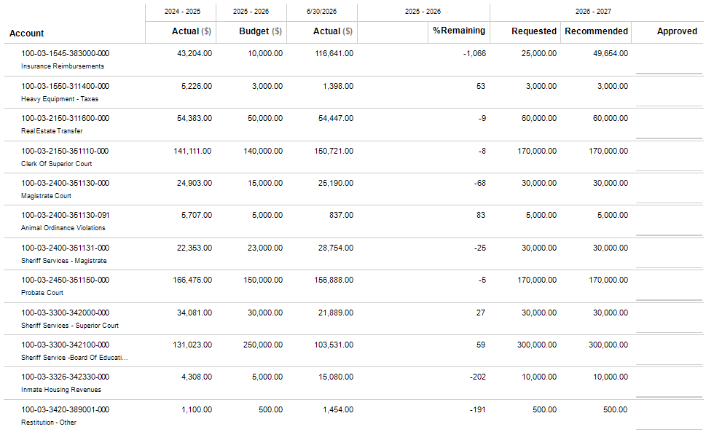
General Fund Revenues – Detail Continued
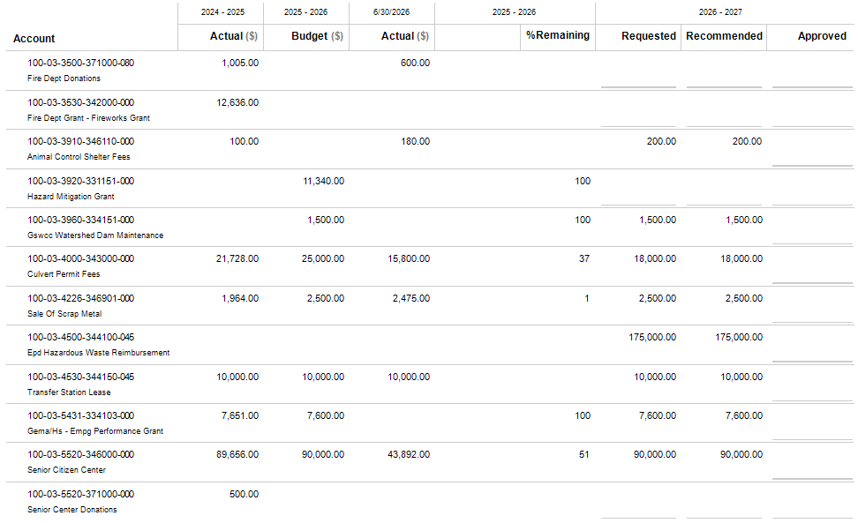
General Fund Revenues – Detail Continued
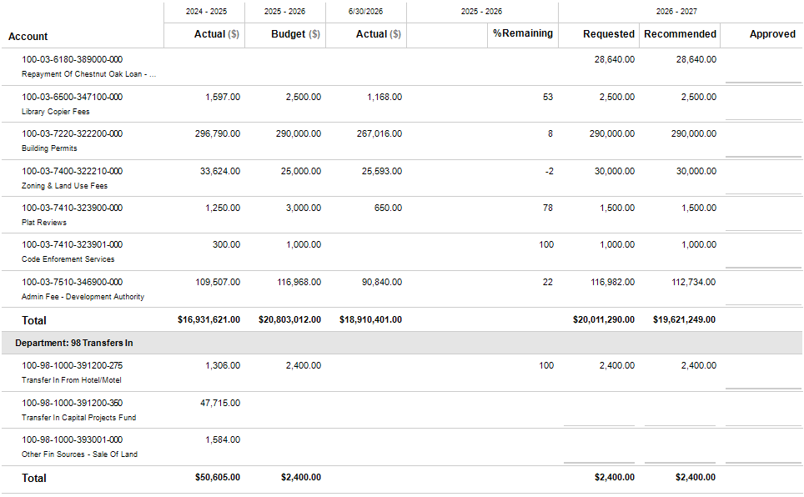
General Fund Revenues – Detail Continued

General Fund Expenditures by Type
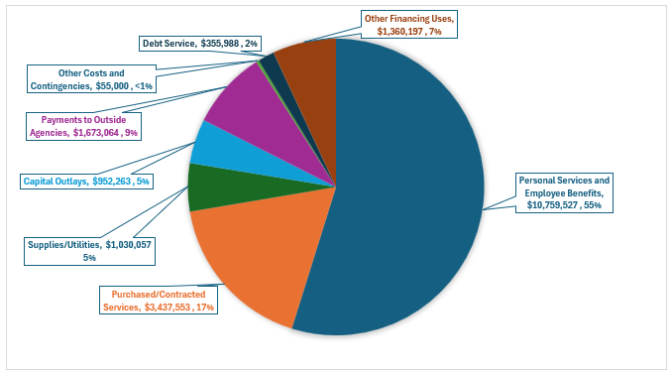

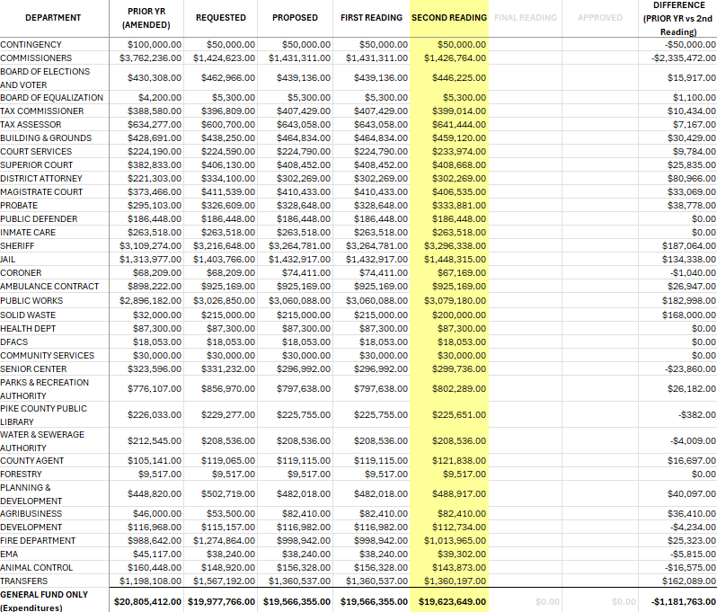
General Fund Expenditures by Type

General Fund
Departmental Budgets of the General Fund
and Outside Agencies

Animal Control
DEPARTMENT PROFILE
The Animal Control Department enforces the county’s animal control ordinance on a countywide basis including all municipalities. This department responds to complaints regarding nuisance animals, animal cruelty, animal bites, and rabies exposure in conjunction with the local Health Department.
STAFFING PLAN
Position Title | FY 24-25 | FY 25-26 | FY 26-27
Director | 1 | 1 | 1
Officer (Full Time) | 1 | 1 | 1
Total Positions | 2 | 2 | 2

BUDGET HIGHLIGHTS
- Officer Position will work on a part-time basis with Planning & Development

- With the purchase of a new Public Works truck, a truck will be transferred to Animal Control

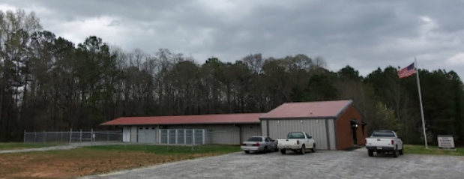

Animal Control - Detail
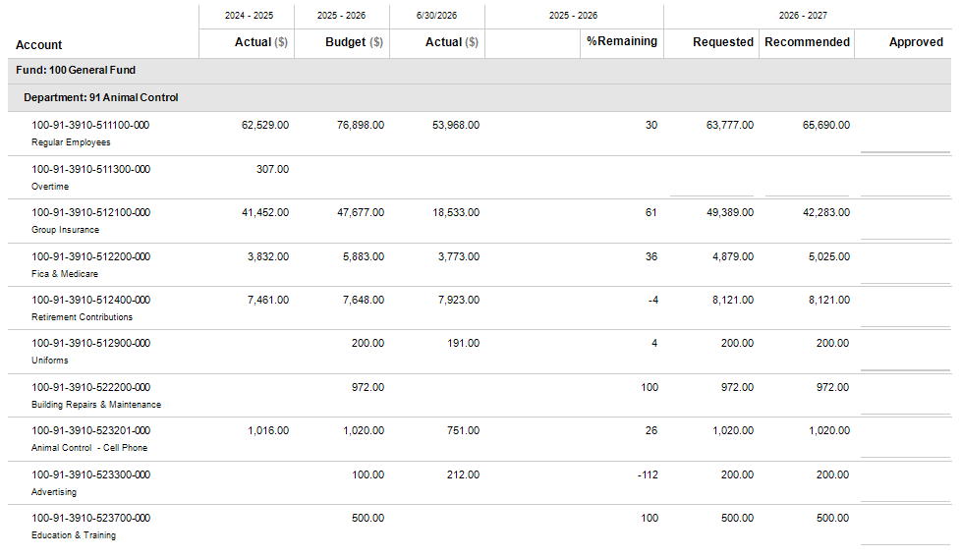

Animal Control – Detail Continued
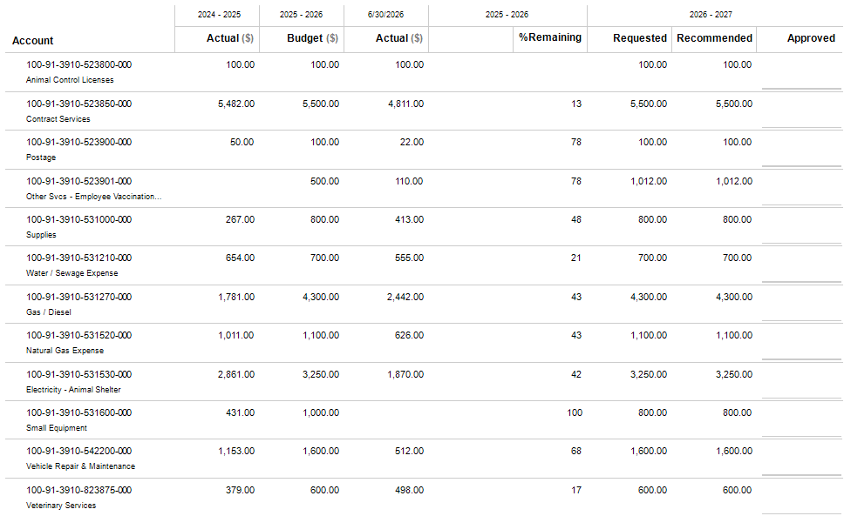

Animal Control – Detail Continued

Board of Commissioners/Administration
DEPARTMENT PROFILE
This department performs the administrative functions for the county and is composed of many facets including the appointed County Manager who implements Board policy, supervises the daily operations of the departments under the Board’s jurisdiction, coordinates activities among those departments, elected officials, and outside agencies, supervises major projects, and prepares and monitors the annual budget. The appointed County Clerk serves as clerk to the Board, prepares commission agendas, records all commission meetings, prepares commission meeting minutes, maintains county records, and responds to open records requests. This department is also responsible for the recruitment and training of new employees for all county departments, prepares all payroll documents, maintains employee records, and administers all employee benefits. This department performs the total accounting and finance functions for the county including processing account receivables and account payables, coordinating the annual audit, maintaining fixed asset records, preparing bids and RFPs/RFQs, and preparing various financial reports required by federal, state, and other regulatory agencies. In addition, this department also funds the County Attorney. The primary function of the County Attorney is to provide legal advice to and to represent Pike County. In doing so, the County Attorney's duties include advising and representing the governing authority, Sheriff, Tax Commissioner, Clerk of Superior Court, Probate Court Judge, officials, and employees of the County. The County Attorney's duties also include advising the governing authority and other County officers and employees on their powers and duties under the law, to prepare ordinances and legal documents, to review proposed contracts and to represent the County and its officers in legal proceedings.

STAFFING PLAN
Position Title | FY 24-25 | FY 25-26 | FY 26-27
County Manager | 1 | 1 | 1
County Clerk | 1 | 1 | 1
Human Resources/Payroll | 1 | 1 | 1
Accounts Payable | 1 | 1 | 1
Finance Administrator | 1 | 1 | 1
County Attorney | 1 | 1 | 1
Commissioners (Elected) | 5 | 5 | 5
Total Positions | 11 | 11 | 11

BUDGET HIGHLIGHTS
- $2,319,569 bank loan on the +/- 238 acres: County Farm Road property paid off during FY25-26.

- The total county Health Reimbursement Account (HRA) has been separated to each department in which the employee works for better transparency and more accurate department costs. Total budgeted cost for FY26-27 is $79,000.

Board of Commissioners/Administration
Continued:
- County is expecting a 10% increase in Property & Liability Insurance

- Defined Benefit has been separated into each department in which the employee works for better transparency and more accurate departmental costs. Total cost is estimated at $624,537.

- 5.3% increase in group insurance, which was changed to CIGNA and shopped by our new broker. The total cost of county group insurance is budgeted at $1,885,513.

- Finalizing a salary study through the UGA Carl Vinson Institute of Government.

- A 3% C.O.L.A. for county employees has been included in the budget.

- The Insurance Premium Tax is budgeted to be collected at a rate of $1,690,000. Per SB 285, all local governments are mandated to remit 1.5% of their insurance premium tax to the Peace Officers’ Annuity and Benefit (POAB) Fund. In accordance with O.C.G.A. 33-8-8.3, the insurance premium tax shall be separated from other funds and shall be expended as follows:

Service | FY2026-27 Budgeted  Expenditures | FY2026-27 Budgeted Revenues | Insurance Premium Tax | Other General Fund Revenues
Sheriff’s (P.O.A.B) | 25,350 | 0 | 25,350 | 0
Ambulance | 925,169 | 0 | 496,803 | 428,366
Fire Dept. | 998,942 | 0 | 536,418 | 462,524
E-911 | 1,197,735 | 402,270 | 631,429 | 164,036
Total | 3,147,196 | 402,270 | 1,690,000 | 1,054,926



Board of Commissioners/Administration - Detail
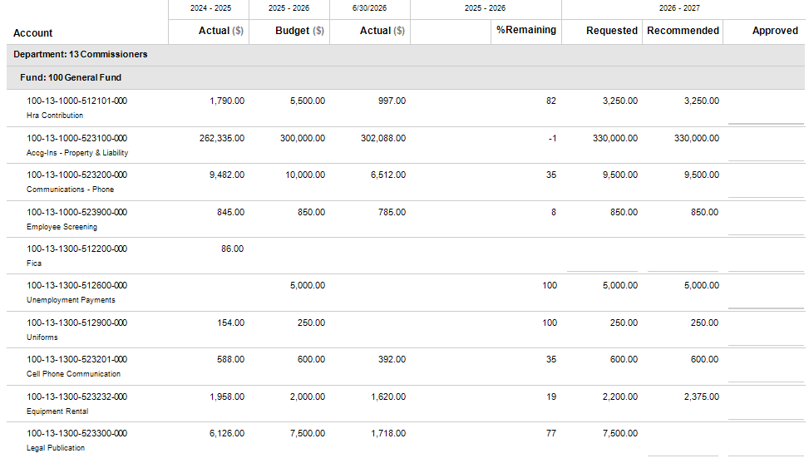

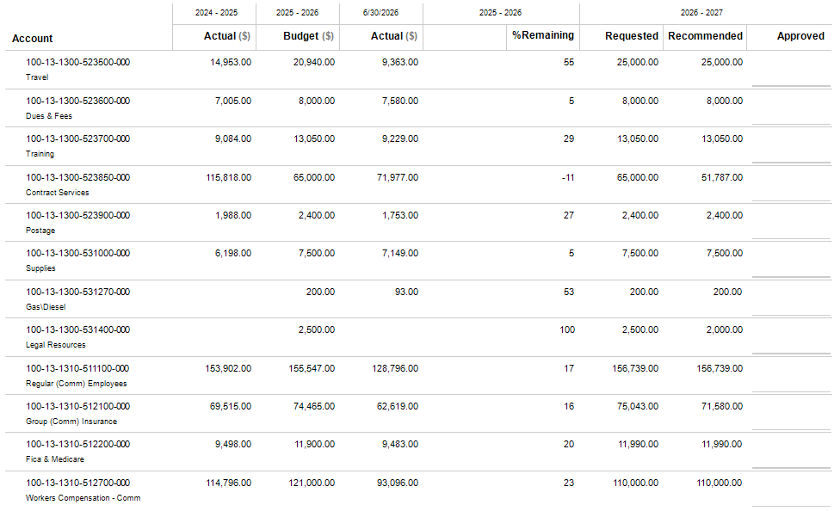
Board of Commissioners/Administration – Detail Continued

Board of Commissioners/Administration – Detail Continued
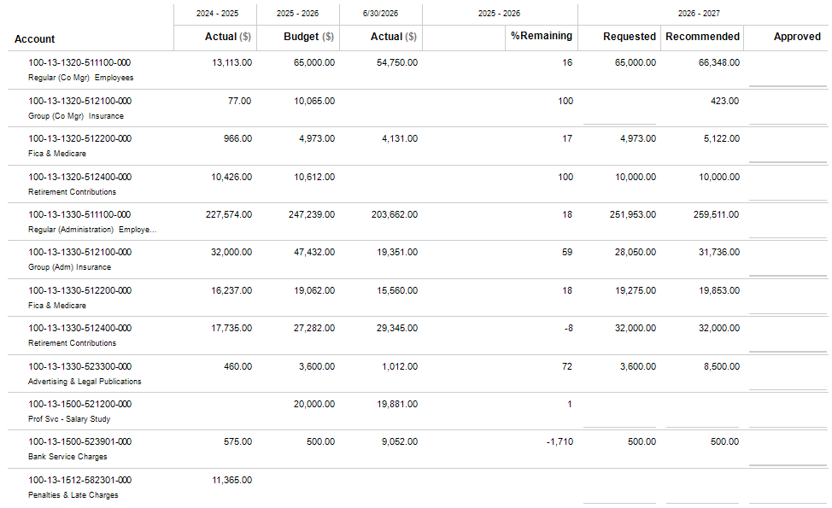

Board of Commissioners/Administration – Detail Continued
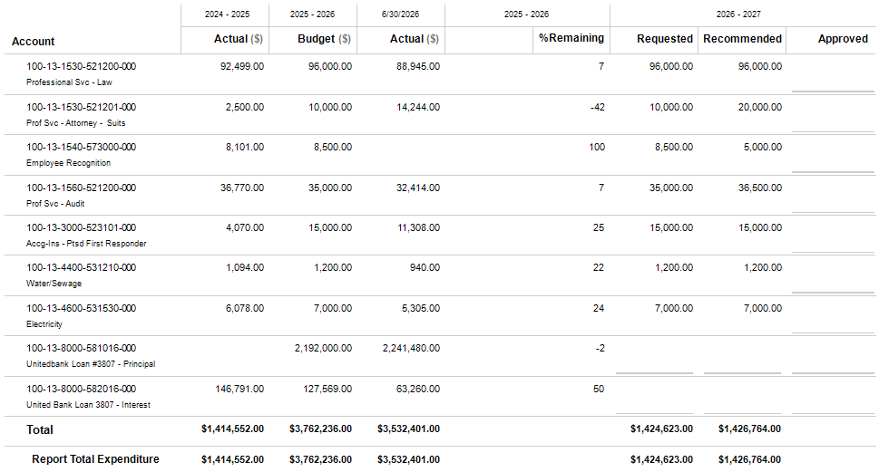

Board of Elections and Registration
DEPARTMENT PROFILE
Pursuant to House Bill 623 (as passed House and Senate and signed into law by the Governor on May 7, 2019), and pursuant to subsection (b) of Code Section 21-2-40 of the O.C.G.A., “The Pike County Board of Elections and Registration” was duly established by Local Legislation with the effective date of July 1, 2019. Membership. The Pike County Board of Elections and Registration shall be composed of five members, each of whom shall be an elector and resident of Pike County and shall be appointed by the Pike County Board of Commissioners. Each member of the board shall be appointed to serve four-year (4-year) terms. An Administrative Supervisor, known as Elections and Registration Supervisor (Supervisor), shall be hired by the County Manager and the Pike County Board of Commissioners to administer and conduct the elections, primaries, and registration of Pike County. Said Supervisor shall be recommended by the Board of Elections to the County Manager and Board of Commissioners. The governing authority of the county shall expend public funds to provide the Supervisor with such proper and suitable administrative offices and with such assistants and other employees as the governing authority shall deem appropriate. Compensation for such administrative personnel shall be paid by the governing authority under its personnel policies wholly from county funds.

STAFFING PLAN
Position Title | FY 24-25 | FY 25-26 | FY 26-27
Elections Supervisor | 1 | 1 | 1
Registrar (Full-Time) | 1 | 1 | 1
Registrar (Part-Time) | 1 | 0 | 0
Elections Systems Supervisor | 1 | 1 | 1
Elections Systems Specialist | 0 | 1 | 1
Board Member (Appointed) | 5 | 5 | 5
Poll Manager (Temp) | 8 | 8 | 8
Poll Worker (Temp) | 32 | 32 | 32
Total Positions | 49 | 49 | 49

BUDGET HIGHLIGHTS
- Increases from prior year relate to salaries, insurance and retirement contributions.

- For future elections, advance voting will be held at the Pike County Public Library.

- A requested restructuring of the counter space within the Board of Elections has not been budgeted as no estimate has been received.

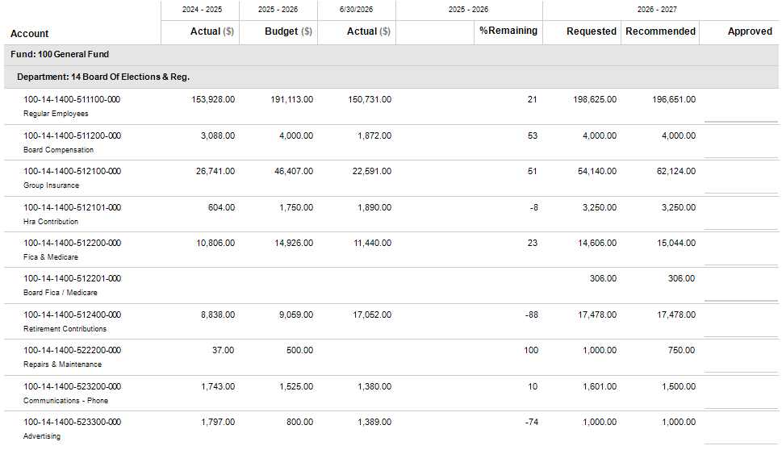
Board of Elections and Registration – Detail

Board of Elections and Registration – Detail Continued

Board of Elections and Registration – Detail Continued

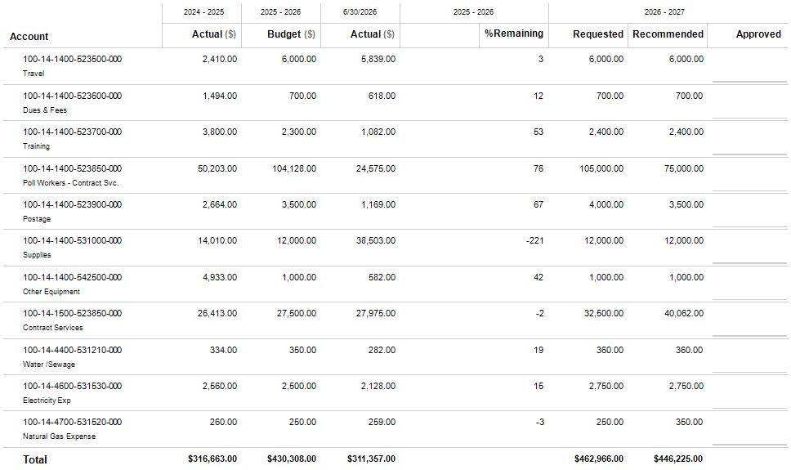
Board of Elections and Registration – Detail

Board of Elections and Registration – Detail

Board of Equalization
DEPARTMENT PROFILE
This six-member board (three members and three alternates) is appointed by the Grand Jury for three-year terms and receives oversight from the Clerk of Superior Court. This Board hears taxpayer appeals regarding property value assessments made by the Board of Tax Assessors and can take action to obtain property value uniformity. Board of Equalization decisions may be appealed to Superior Court.
STAFFING PLAN
Position Title | FY 24-25 | FY 25-26 | FY 26-27
Board Member | 6 | 6 | 6
Total Positions | 6 | 6 | 6

BUDGET HIGHLIGHTS
- A printing and binding account was added this year for the Board’s usage.



Board of Equalization - Detail
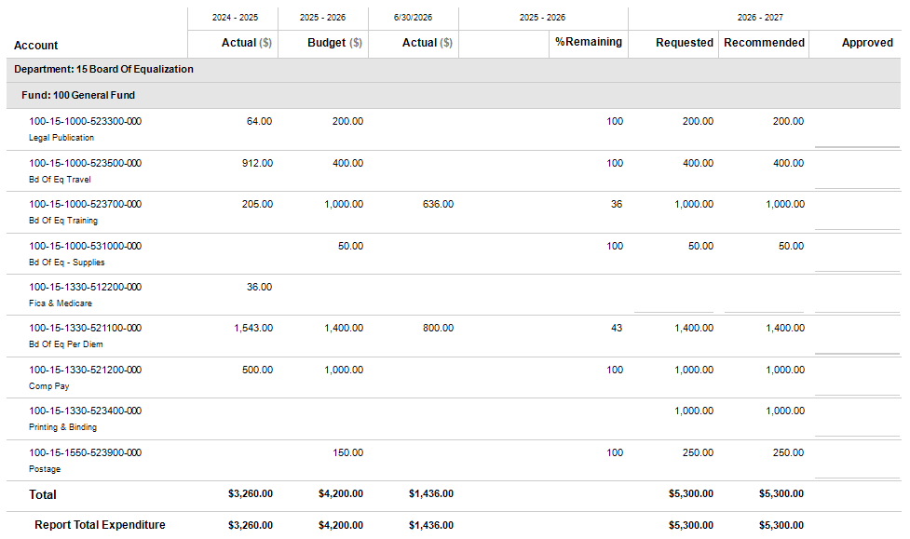

Building and Grounds
DEPARTMENT PROFILE
The Building and Grounds Department maintains approximately 21+/- county-owned buildings, performs county-wide preventive maintenance functions, and provides janitorial services for the courthouse, courthouse annex, administration building, and the health department building. This department also constructs small projects, conducts minor renovations, assists with major renovations, and resolves building related complaints on a county-wide basis.
STAFFING PLAN
Position Title | FY 24-25 | FY 25-26 | FY 26-27
Director | 1 | 1 | 1
Facilities Maintenance Technician | 1 | 1 | 1
Building Service Worker | 1 | 1 | 1
Total Positions | 3 | 3 | 3

BUDGET HIGHLIGHTS
- Increases from prior year relate to salaries and insurance

- Maintenance Repairs/Expenditures – All Facilities is budgeted at $34,000 for upkeep and maintenance of all county facilities. The following projects are also budgeted within this line item:

- Replacement of Health Department door $8,000

- New carpet in courthouse courtroom $15,000

- Probate court upstairs office carpet $3,000

- Septic fill line replacement $7,000

- Courthouse north tree trimming/removal $5,000

- Library water check value $4,000

- Transfer Station building repair $5,000

- Various HVAC System replacements $15,000

Building and Grounds - Continued

- Building and Grounds storage building lean-to $30,000

- A requested restructuring of the counter space within the Board of Elections has not been budgeted as no estimate has been received.

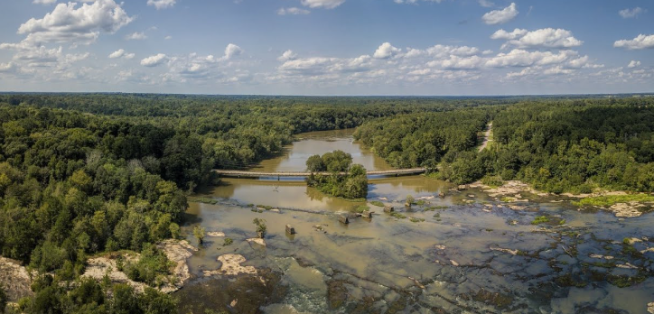

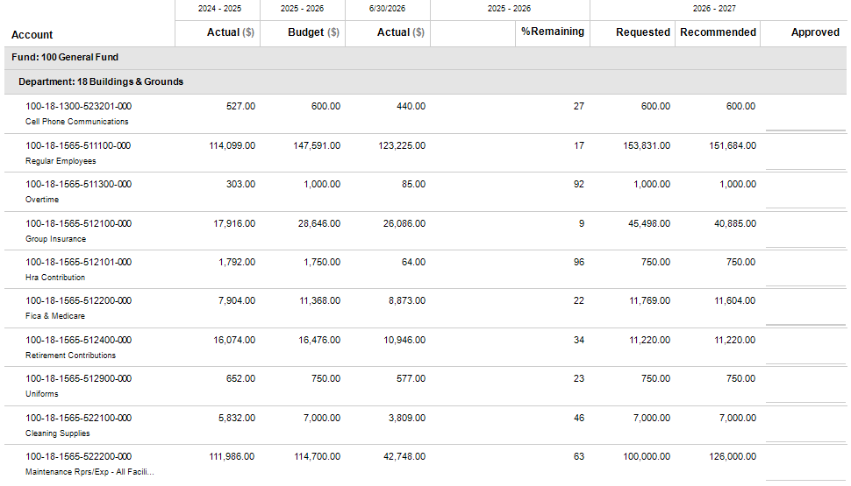
Building and Grounds – Detail

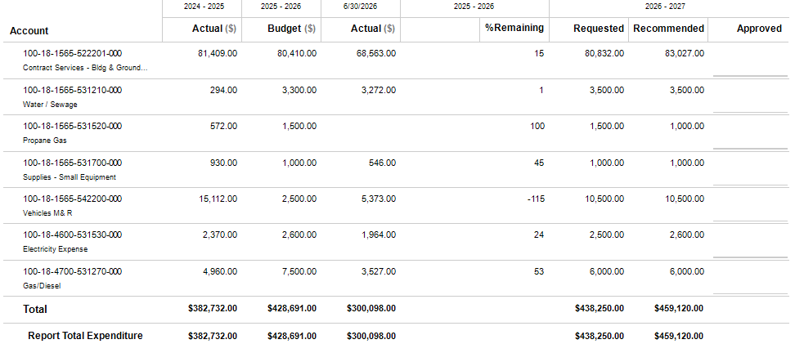
Building and Grounds – Detail Continued

Coroner
DEPARTMENT PROFILE
The coroner is elected by the voters for four-year terms. The Coroner, with the assistance from the Georgia Bureau of Investigations and other state and local agencies, investigates the cause and manner of death when a person dies under various situations including but not limited to: 1) as a result of violence, suicide, or accident, 2) suddenly when in apparent good health, 3) when unattended by a physician, 4) in any suspicious manner, or 5) as a result of an apparent drug overdose.
STAFFING PLAN
Position Title | FY 24-25 | FY 25-26 | FY 26-27
Coroner (Elected) | 1 | 1 | 1
Deputy Coroner | 2 | 2 | 3
Total Positions | 3 | 3 | 4

BUDGET HIGHLIGHTS
- Deputy Coroners are paid $175 per call from contract services

- There is a need for a new van within this department but it is not currently budgeted.



Coroner – Detail
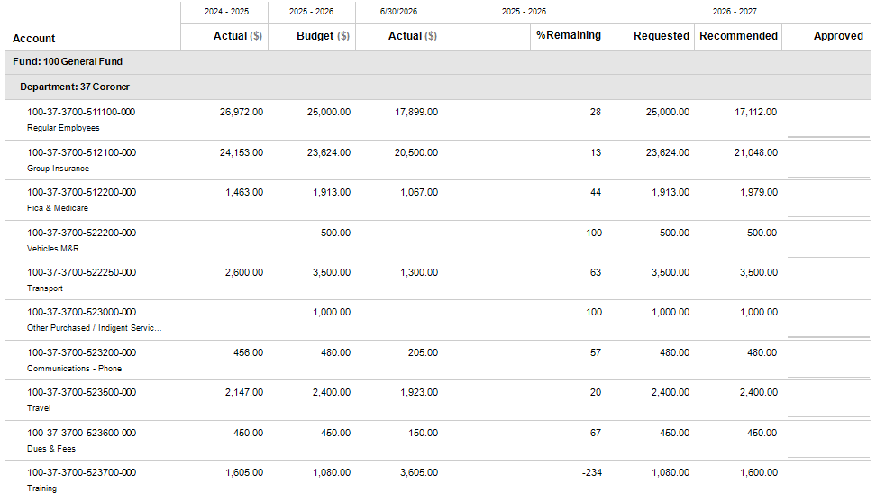

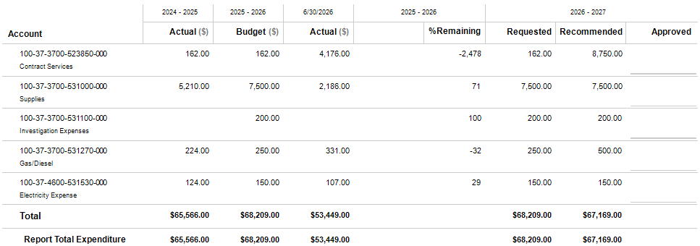
Coroner – Detail Continued

Clerk of Superior Court
DEPARTMENT PROFILE
The Clerk of Superior Court is a constitutional officer and is elected by the voters for four-year terms. This office maintains Superior Court records, transmits all appeals to the Georgia Court of Appeals and Georgia Supreme Court, and records real estate transactions such as warranty deeds, quit claim deeds, security deeds, assignments, right-of-way deeds, easements, property plats, and power of attorney documents. In addition, this office is also responsible for recording military discharges, trade names, UCCs, and various sorts of liens including mechanic liens, property tax liens, and hospital/doctor liens. In addition, this office also collects probation fines, child support payments, and property transfer taxes. This elected office also files criminal cases, maintains criminal warrants, and transmits documents to GCIC and the DMV. This office also files civil cases such as divorces/annulments, adoptions, child support, name changes, habeas corpus cases, suits for damages, garnishments, and repossessions. This office also issues notary appointments, performs jury management, keeps election ballots for the statutory time limit of two years, and assists the public with obtaining various court records. Lastly, this office provides administrative support to the Board of Equalization.
STAFFING PLAN
Position Title | FY 24-25 | FY 25-26 | FY 26-27
Clerk of Court | 1 | 1 | 1
Civil Clerk | 1 | 1 | 1
Criminal Clerk | 1 | 1 | 1
Juvenile Clerk | 1 | 1 | 1
Real Estate Clerk | 1 | 1 | 1
Total Positions | 5 | 5 | 5

BUDGET HIGHLIGHTS
- Clerk of Superior Court’s employee salaries have been raised approximately 4.2% collectively

- Increases from prior year relate to salaries and insurance

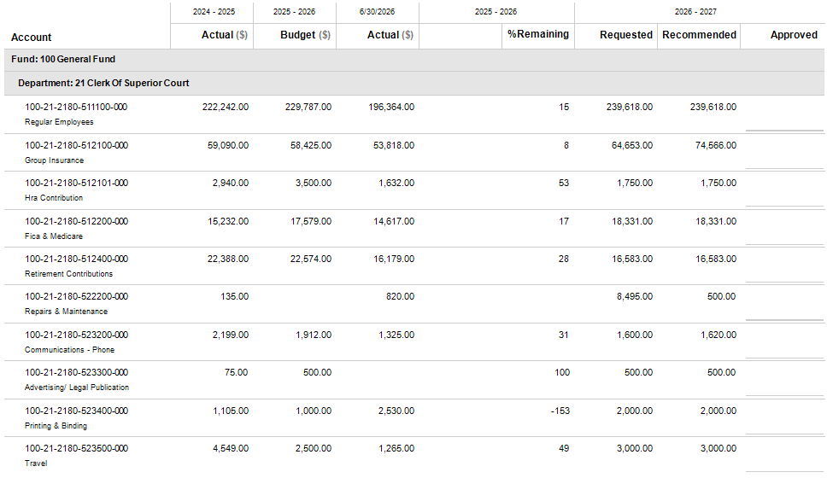
Clerk of Superior Court – Detail

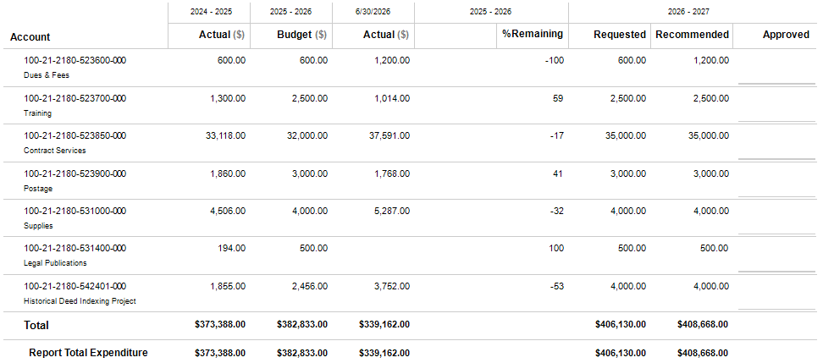
Clerk of Superior Court – Detail Continued

Court Services
DEPARTMENT PROFILE
The Court Services department services budgets (covering Superior, Magistrate, Probate, and Juvenile courts) are funded primarily through local property taxes, supplemented by fees, with significant expenditures directed toward personnel, technology, and administration. Specifically, the Superior Court, in the Griffin Judicial Circuit serving Fayette, Pike, Spalding and Upson counties, possesses appellate jurisdiction from judgements of the Probate Court and Magistrate Court and this court is empowered to exercise general supervision over all inferior courts and to review and correct their judgments. The Superior Court also appoints Juvenile Court Judges to hear juvenile cases.
STAFFING PLAN
Position Title | FY 24-25 | FY 25-26 | FY 26-27
No Positions in this Department | 0 | 0 | 0
Total Positions | 0 | 0 | 0

BUDGET HIGHLIGHTS
- Professional services expenditures include $10,000 for contracted private entities or specialized staff to assist judges, manage caseloads, and provide supervision for individuals involved in the legal system.

- Pike County’s allocation of total circuit court expenditures totals $118,960 for salaries, supplements, benefits and other expenditures.

- Technical services expenditures include $1,000 for interpreters and $19,000 for court reporters.

- Grand juror per diem payments budgeted at $10,000 are now handled through a debit card system program.

- A Guardian ad Litem has been appointed to represent juveniles at a cost of $26,000.

Court Services – Detail
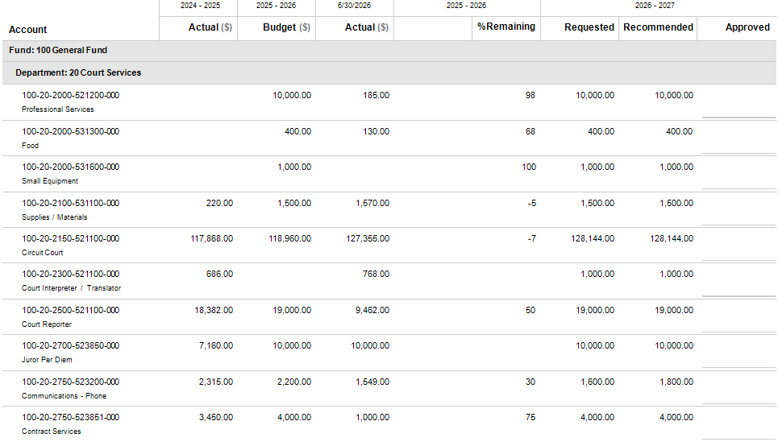
Court Services – Detail Continued
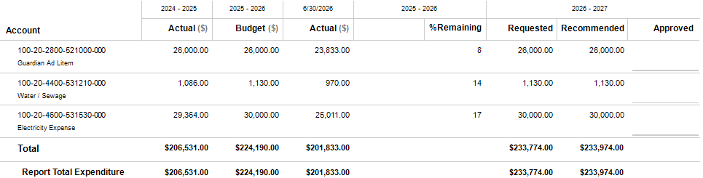

District Attorney
DEPARTMENT PROFILE
The District Attorney is elected by the voters of the Griffin Judicial Circuit that consists of Fayette, Pike, Spalding, and Upson counties for a four-year term. The District Attorney represents the state in all criminal cases in Superior Court and in all cases taken up from Superior Court to the Georgia Court of Appeals and the Georgia Supreme Court. The District Attorney advises grand juries in relation to matters of law, prepares indictments or presentments when requested by the grand jury, prosecutes all indictable offenses, prosecutes, or defends any civil action in which the state is interested, argues criminal cases on appeal, and assists the Attorney General when certain prosecutions are transferred to a U.S. District Court. The District Attorney also supervises the county’s Victim-Witness Assistance Program.
STAFFING PLAN
Position Title | FY 24-25 | FY 25-26 | FY 26-27
District Attorney (Elected) | 1 | 1 | 1
Investigator | 1 | 1 | 1
Chief Assistant District Attorney | 1 | 1 | 1
Executive Assistant to District Attorney | 1 | 1 | 1
Assistant District Attorney | 2 | 2 | 2
Legal Secretary | 1 | 1 | 1
Victim Witness Advocate (Requesting) | 0 | 0 | 1
Total Positions | 7 | 7 | 8

BUDGET HIGHLIGHTS
- A full-time Victim Witness Advocate position plus benefits has been added.

- Operational expenditures have been increased and also include the addition of an Axon Justice digital evidence storage database.

District Attorney – Detail
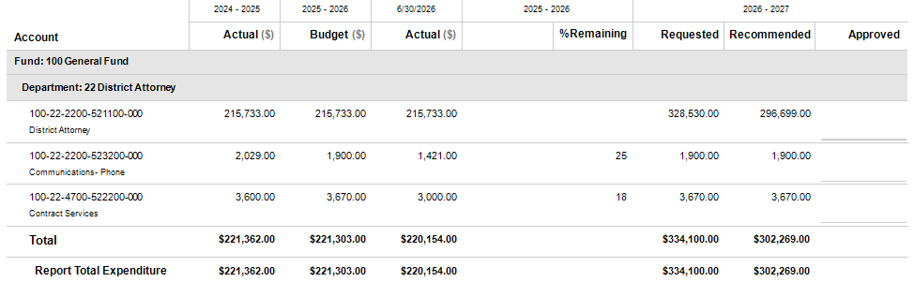

Emergency Management Agency
DEPARTMENT PROFILE
The Pike County Emergency Management Agency (EMA) is committed to the protection of life, property, and the environment for the citizens of Pike County. The EMA demonstrates this commitment by meeting or exceeding emergency management standards in the areas of mitigation, preparedness, response, and recovery. This department is operated by an unpaid volunteer and is funded by grants and local supplements.
STAFFING PLAN
Position Title | FY 24-25 | FY 25-26 | FY 26-27
Director (Volunteer) | 1 | 1 | 1
Total Positions | 1 | 1 | 1

BUDGET HIGHLIGHTS
- Contract services expenditures of $12,000 include the Code Red emergency notification system.

- EMPG Grant expenditures of $18,995 are budgeted for annual administration, preparedness activities and exercises/training.

- For planning purposes, future compensation for the EMA director should be considered to ensure sustainable leadership and continued emergency preparedness efforts.



Emergency Management Agency – Detail
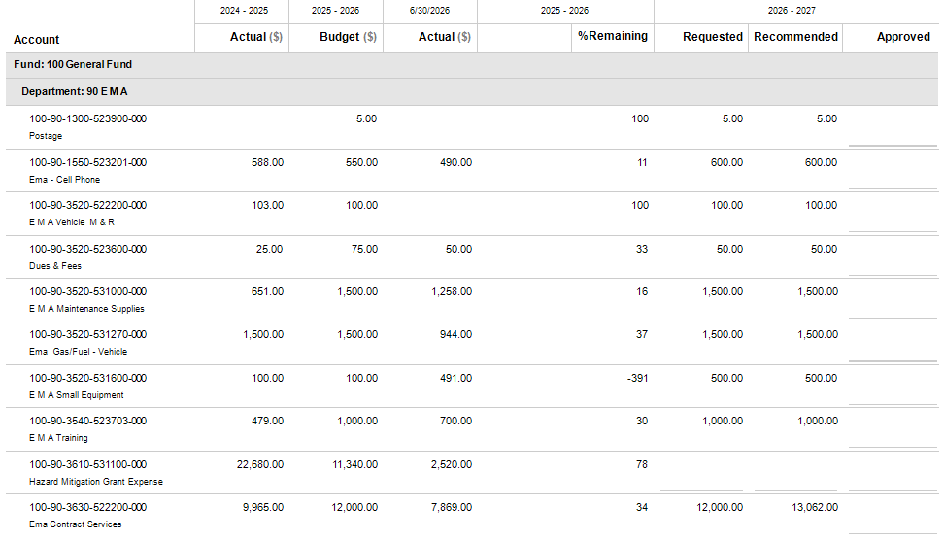
Emergency Management Agency – Detail Continued
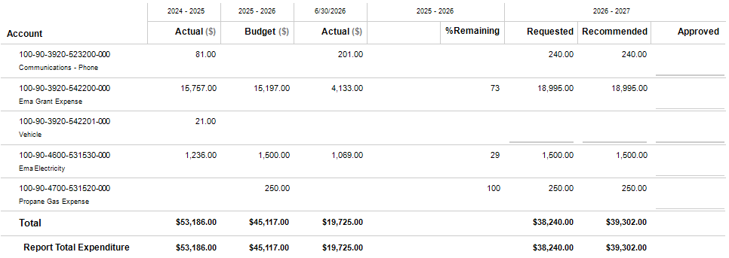

Fire Department
DEPARTMENT PROFILE
Pike County Fire Department has a mutual aid agreement with the City of Meansville’s volunteer fire department, and together they provide fire protection to the incorporated and unincorporated areas of the county. The two fire departments currently maintain 8 stations located throughout the county. The county provides each station with annual stipends for their operations and equipment purchases, performs repairs on the vehicles and equipment, funds property insurance for the vehicles and stations as well as workers’ compensation insurance, accident and sickness insurance, cancer insurance and PTSD coverage.
STAFFING PLAN
Position Title | FY 24-25 | FY 25-26 | FY 26-27
Chief | 1 | 1 | 1
Deputy Chief | 1 | 1 | 1
Training Officer | 1 | 1 | 1
Paid Part-Time Fire Fighter | 27 | 29 | 30
Volunteer Fire Fighter | 37 | 37 | 37
Total Positions | 67 | 69 | 70

BUDGET HIGHLIGHTS
- Requesting 24/7 coverage 4 personnel – 2 Stations (2 at Zebulon / 2 at Concord). An increase of $280,295. The increase is not currently budgeted but could be funded by an approximately 0.3 mil increase.

- If request is approved, utilities budget would need to adjust accordingly.
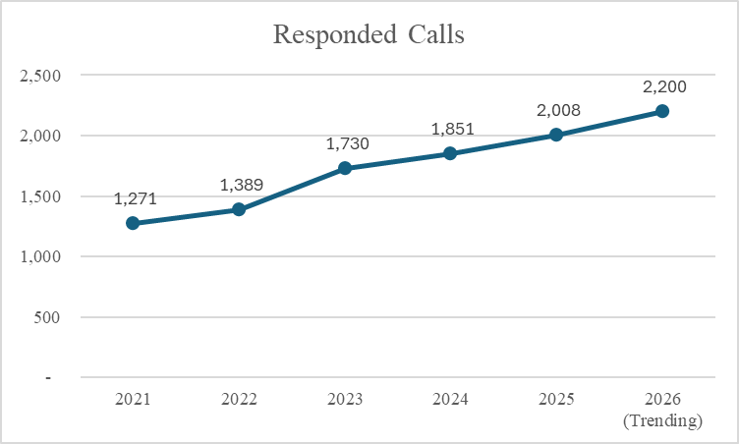
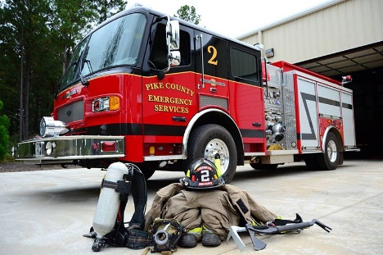

Fire Department – Detail
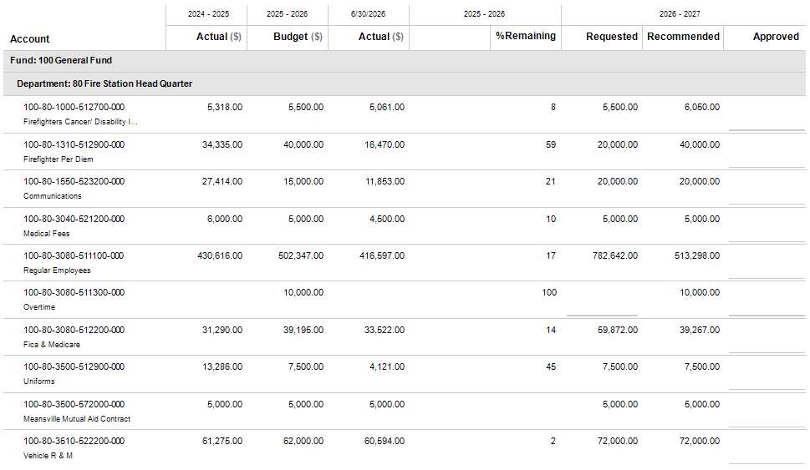
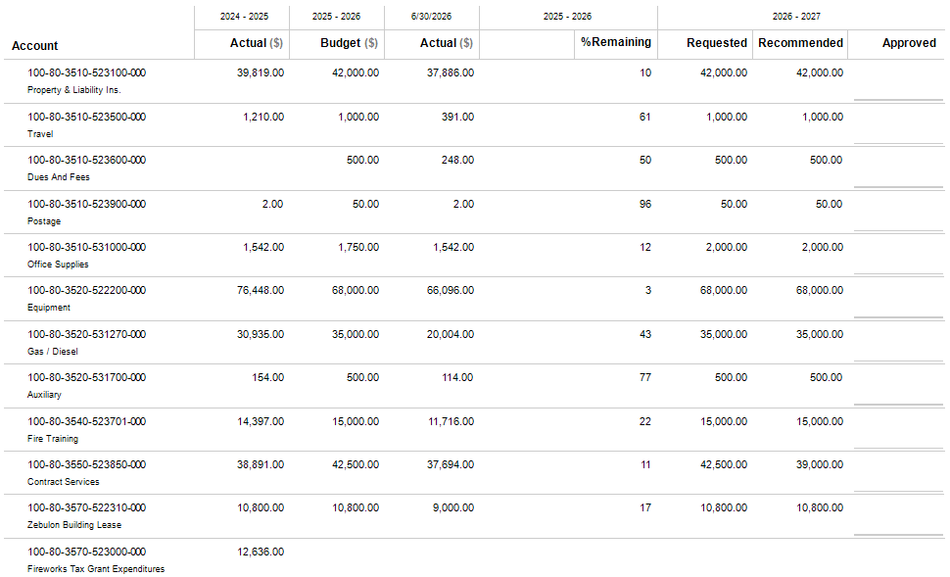
Fire Department – Detail Continued

Fire Department – Detail Continued
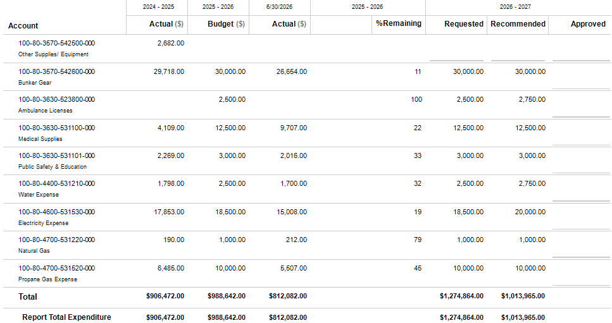

Inmate Care
DEPARTMENT PROFILE
Per Georgia Rules and Regulations subject 125-4-4 Medical Services: When a person is committed to a correctional institution it becomes the responsibility of the correctional authorities to provide the necessary health care for the inmate. Medical and hospital care, as required, shall be provided for all inmates assigned. In no instance shall an inmate, his family or other individual be required to pay any portion of the fee or expenditures for the inmate’s medical or dental treatment, except as otherwise provided by law.
Position Title | FY 24-25 | FY 25-26 | FY 26-27
No Positions in this Department | 0 | 0 | 0
Total Positions | 0 | 0 | 0
STAFFING PLAN

BUDGET HIGHLIGHTS
- No significant changes from the previous fiscal year.

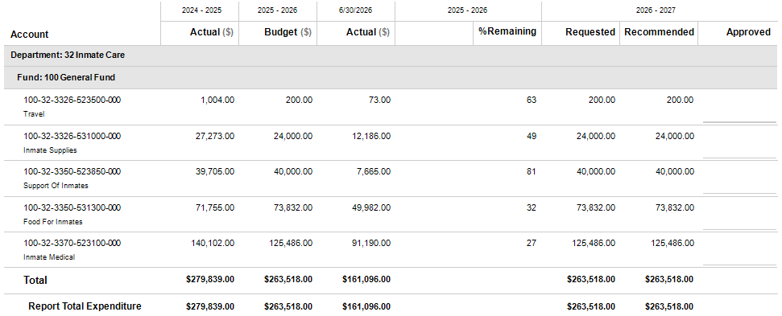
Inmate Care - Detail

Jail
DEPARTMENT PROFILE
The current county jail, under the direction of the elected Sheriff, is a 32 bed facility that is a holding facility for 30 men and 2 women. This facility houses inmates with pre-trial criminal offense(s) ranging from city violation(s), county ordinance(s) violation(s) including misdemeanors up to felony charge(s). In addition the jail houses for the City of Zebulon and City of Molena when they are awaiting court appearance and for persons already sentenced but waiting for a transfer to a state facility. The county jail also holds persons found guilty of certain misdemeanors, county ordinance, and probation violation sentenced to county jail to twelve months or less. This facility does not house juveniles.
STAFFING PLAN
Position Title | FY 24-25 | FY 25-26 | FY 26-27
Department Supervisor (Major) | 1 | 1 | 1
Shift Supervisor | 4 | 4 | 4
Jailers | 10 | 10 | 10
Court Services | 2 | 3 | 3
Total Positions | 17 | 18 | 18

BUDGET HIGHLIGHTS
- Increases from prior year relate to salaries, insurance, retirement contributions, uniforms and utilities.

- Contract services include $15,500 for an annual maintenance agreement on a public safety software solution, $8,580 for computer support and IT services, $2,400 for copier services, $1,800 for waste removal, $1,102 for less-lethal weapon technologies and $1,868 for professional personnel assessments.

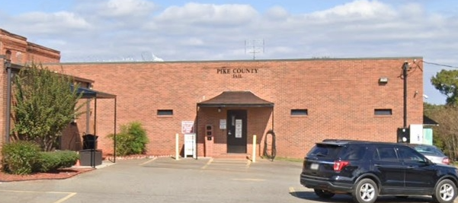

Jail - Detail
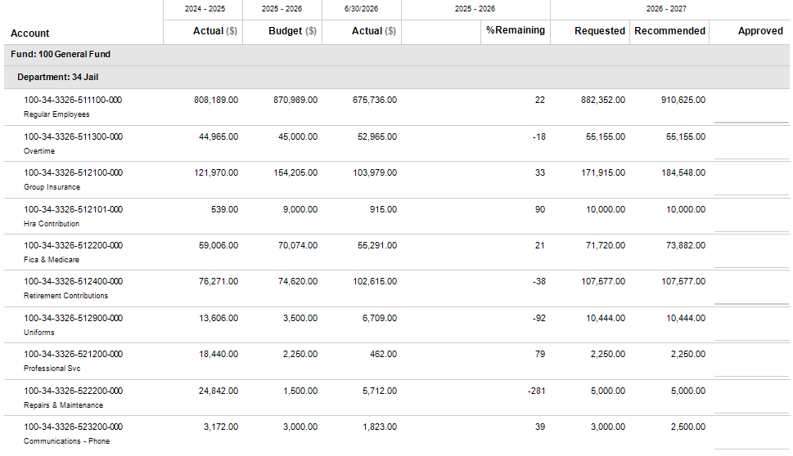
Jail – Detail Continued
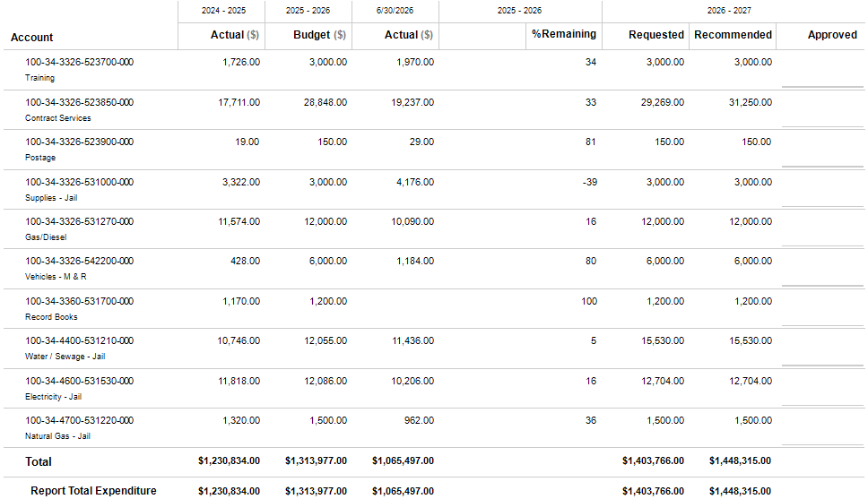

Magistrate Court
DEPARTMENT PROFILE
The Chief Magistrate of the Magistrate Court is elected by the voters for four-year terms. The Magistrate Court has criminal and civil jurisdictions. The criminal jurisdiction’s responsibilities include issuing arrest and search warrants as well as good behavior bonds, conducting first appearances, setting bonds, extradition, committal, and warrant application hearings, and presiding over and conducting trials for county ordinance violations, misdemeanor bad checks, criminal trespass, alcohol beverage violations involving persons under 21 years of age, shoplifting, and possession of marijuana less than one ounce. The civil jurisdiction’s responsibilities include the trial and adjudication of civil claims for $15,000 or less, dispossessory and distress warrant proceedings, abandoned vehicles, foreclosures, and garnishments.
STAFFING PLAN
Position Title | FY 24-25 | FY 25-26 | FY 26-27
Chief Magistrate Judge (Elected) | 1 | 1 | 1
Non-Chief Magistrate Judge (Appointed)) | 1 | 1 | 1
Magistrate Court Clerk | 2 | 2 | 3
Total Positions | 4 | 4 | 5

BUDGET HIGHLIGHTS
- The Chief Magistrate is requesting an additional part-time position at $32,255.
- Other increases from prior year relate to insurance.



Magistrate Court - Detail
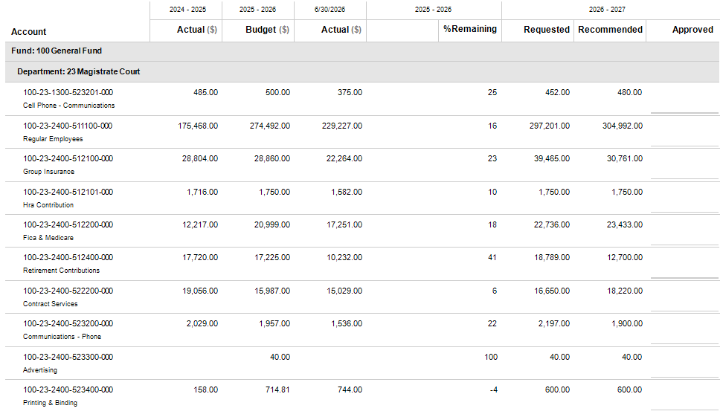
Magistrate Court – Detail Continued
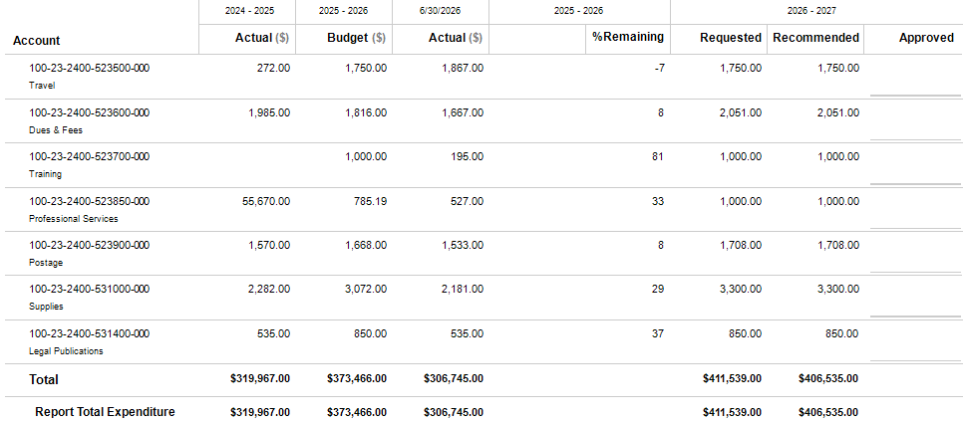

Planning and Development
DEPARTMENT PROFILE
The Planning & Development Department handles permitting, planning and development, code enforcement, building inspections, erosion, and soil (E&S) issues, and land disturbance permits. They are involved in planning both residential and commercial structures, as well as rezoning for subdivisions and other areas. In addition, this department is responsible for issuing and collection of business licenses and is the administrator of the Impact Fee Program.
STAFFING PLAN
Position Title | FY 24-25 | FY 25-26 | FY 26-27
Director | 1 | 1 | 1
Building Inspector/Code Enforcement | 2 | 2 | 2
Code Enforcement Officer (part-time) | 0 | 0 | 1
Administrative Assistant | 2 | 2 | 2
Total Positions | 5 | 5 | 6

BUDGET HIGHLIGHTS
- Added a Part-time Code Enforcement officer that will be shared with Animal Control

- Increases from prior year relate to salaries, insurance and retirement contributions.
- Contract services include $13,500 for an annual maintenance agreement on a planning and zoning management software solution, $8,772 for computer support and IT services and $4,728 for copier services.



Planning and Development - Detail
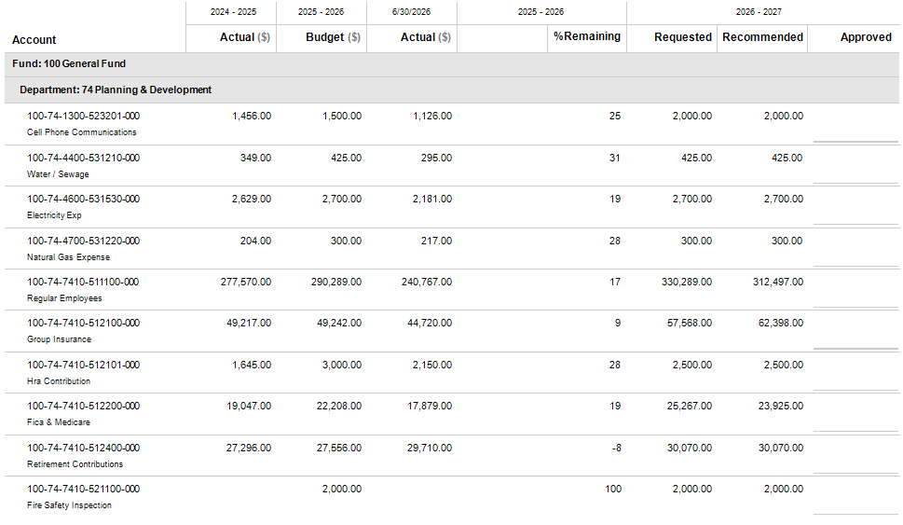

Planning and Development – Detail Continued
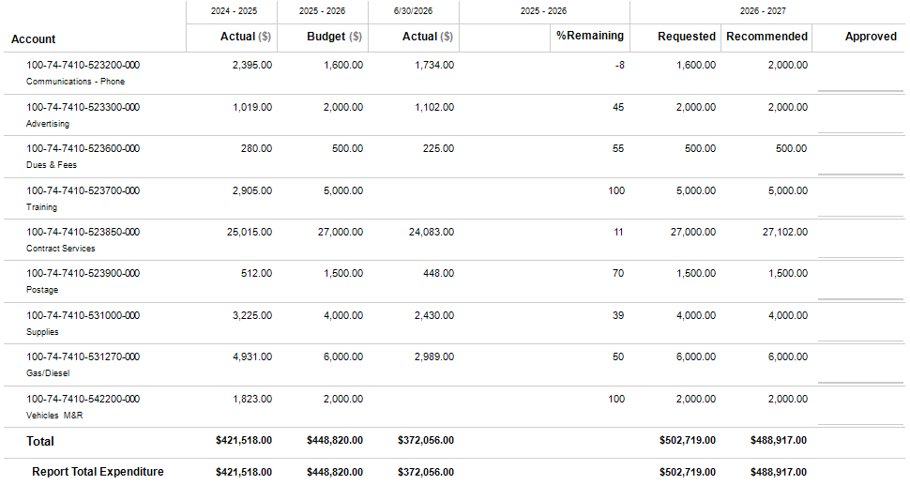

Probate Court
DEPARTMENT PROFILE
The Judge of the Probate Court is a non-partisan constitutional officer elected by the voters of the county to serve four-year terms. The Probate Court has exclusive and original jurisdiction over the probate of wills, administration of estates, and the appointment of guardians and conservators for minors and incapacitated adults. Additionally, the Probate Court hears countywide misdemeanor traffic cases except those in the city limits and other misdemeanor offenses including game and fish violations. This court also issues marriage licenses, weapons carry licenses, residency verifications, and public fireworks display permits. The Judge of the Probate Court also performs various administrative duties such as administering oaths of office to elected officials and approving and recording required bonds of those officials.
STAFFING PLAN
Position Title | FY 24-25 | FY 25-26 | FY 26-27
Probate Judge | 1 | 1 | 1
Probate Court Clerk (Full Time) | 1 | 1 | 0
Probate Court Clerk (Part Time) | 2 | 2 | 3
Total Positions | 4 | 4 | 4

BUDGET HIGHLIGHTS
- Increases from prior year relate to salaries, insurance and retirement contributions.



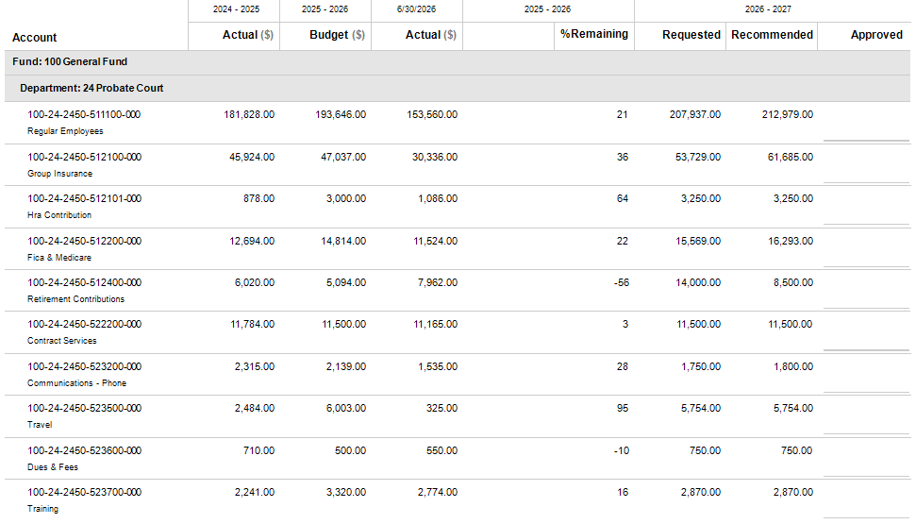
Probate Court - Detail

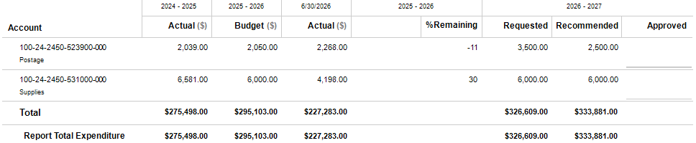
Probate Court – Detail Continued

Public Defender
DEPARTMENT PROFILE
The Griffin Circuit Public Defender’s Office consists of four counties in the circuit (Fayette, Pike, Spalding, and Upson). Pike County provides a portion of the funding for the consolidated, circuit-wide budget each year. The main office is located in Griffin and is headed by William Imhoff.
STAFFING PLAN
Position Title | FY 24-25 | FY 25-26 | FY 26-27
No Positions in this Department | 0 | 0 | 0
Total Positions | 0 | 0 | 0

BUDGET HIGHLIGHTS
- No significant changes from the previous fiscal year.

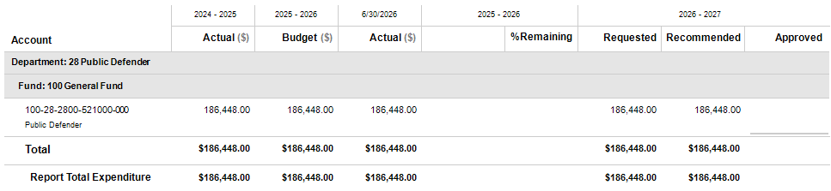
Public Defender - Detail

Public Works
DEPARTMENT PROFILE
The Public Works Department maintains and repairs 192 miles of paved county roads, 200 miles of unpaved county roads, 20 bridge structures, and many culverts and storm drainage pipes in the unincorporated area of the county. This department also mows all county rights-of-ways, maintains ditches, trims trees, installs traffic signs, removes storm debris from county rights-of-way, and conducts in-house projects on an as-needed basis. This department also supervises contracted road and bridge work and large pipe and bridge replacements, prepares the annual LMIG list of resurfacing needs. This department issues driveway, utility encroachment, and timber permits, sells, and installs driveway pipe for installation within the county by private contractors, performs preliminary plan reviews regarding new roads for county acceptance, performs traffic studies, and responds to citizen complaints regarding traffic safety issues.
STAFFING PLAN
Position Title | FY 24-25 | FY 25-26 | FY 26-27
Director | 1 | 1 | 1
Administrative Assistant | 0 | 1 | 1
Road Superintendent | 1 | 0 | 0
Paving Superintendent | 1 | 0 | 0
Light Equipment Operator | 13 | 8 | 6
Heavy Equipment Operator | 4 | 9 | 11
Mechanic | 2 | 2 | 2
Sign Technician | 1 | 1 | 1
Total Positions | 23 | 22 | 22

BUDGET HIGHLIGHTS
- Charging cities for sign materials is under consideration for this budget.

- Increases from prior year relate to insurance.

- Added lease on a new Gradall at $10,216.54/month ($122,599)

- Department requests for a Dump Truck - $203,000 is NOT included within the capital budget. A lease is up for discussion.

- A lease for a new skid steer is needed but the terms have not been agreed upon therefore it is not included in the budget at this time.

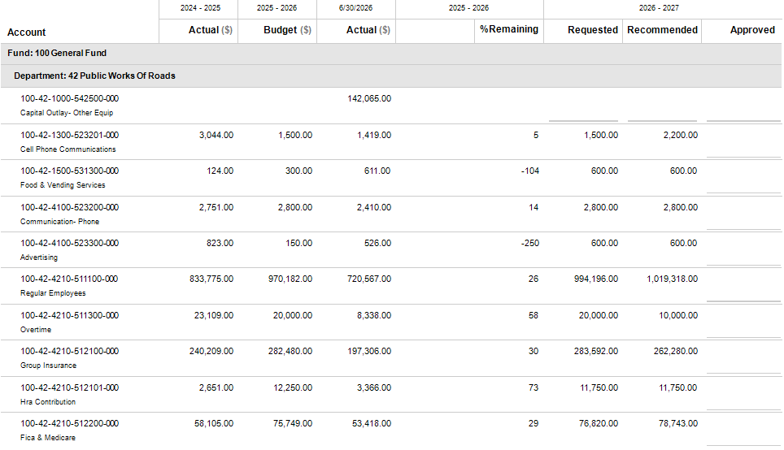
Public Works - Detail

Public Works – Detail Continued

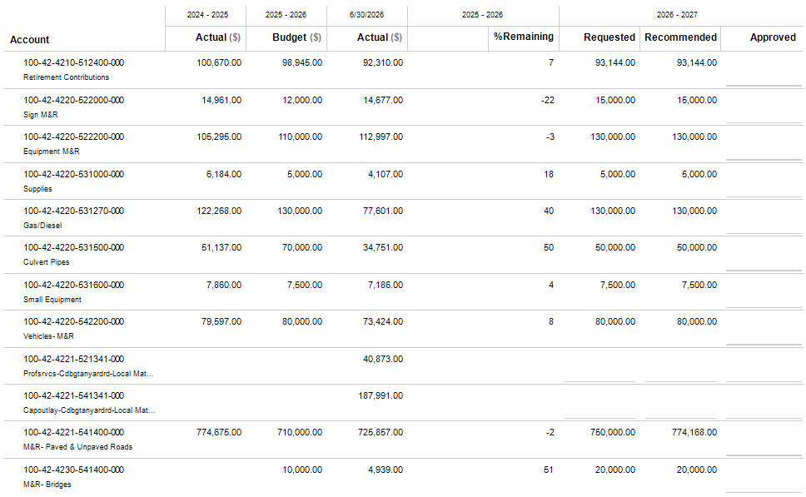
Public Works – Detail Continued

Public Works – Detail Continued
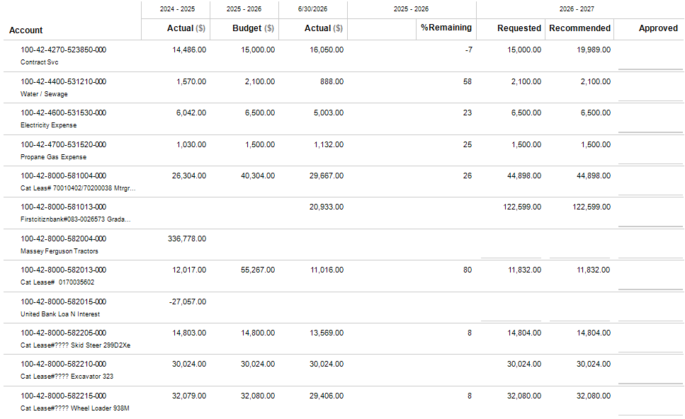
Public Works – Detail Continued
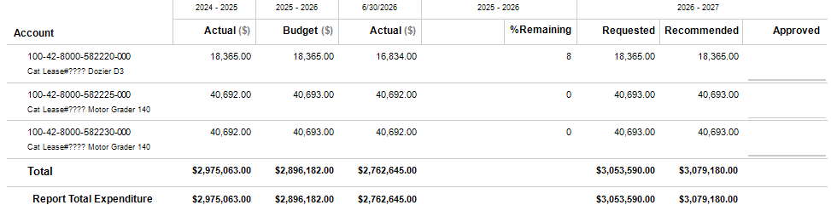

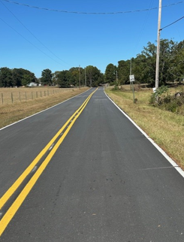
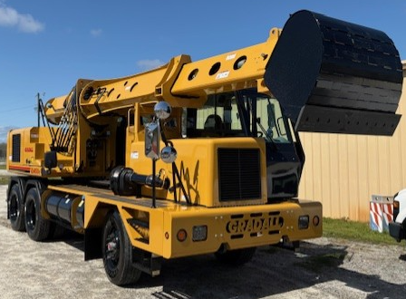

Senior Center
DEPARTMENT PROFILE
The Senior Citizens Center, through a partnership with the Three Rivers Area Agency on Aging, provides many programs for the county’s senior adults. Those programs include physical exercises, arts and crafts, day trips, inspirational speakers, themed parties, bingo games, and noon-time meals. The center also provides home delivered meals to 40 citizens through the Meals-on-Wheels program. The county provides this program with a county-owned building, vehicles, and an annual supplement.
STAFFING PLAN
Position Title | FY 24-25 | FY 25-26 | FY 26-27
Director | 1 | 1 | 1
Administrative Assistant | 1 | 1 | 0
Kitchen Manager | 1 | 1 | 1
Transportation | 2 | 2 | 2
Attendant | 2 | 2 | 2
Total Positions | 7 | 7 | 6

BUDGET HIGHLIGHTS
- Congregate and home delivered meals were researched and expenditures were brought more in line with historical actuals.

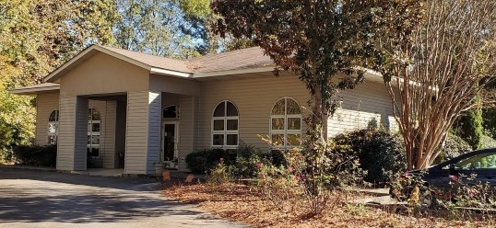

Senior Center - Detail
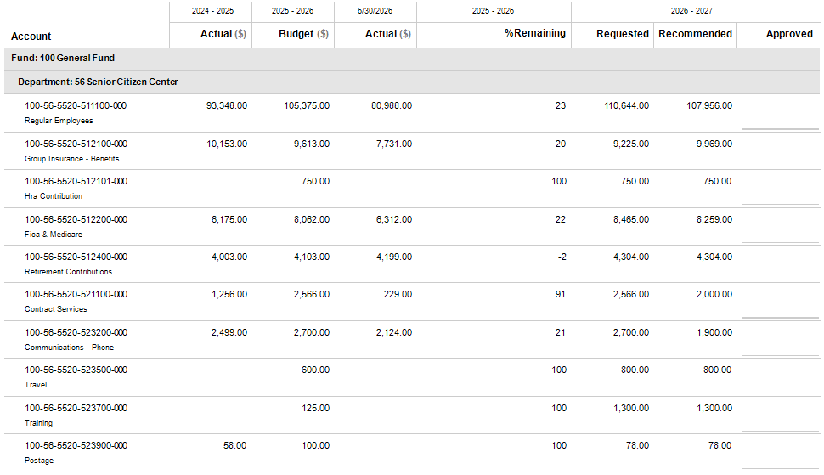

Senior Center – Detail Continued

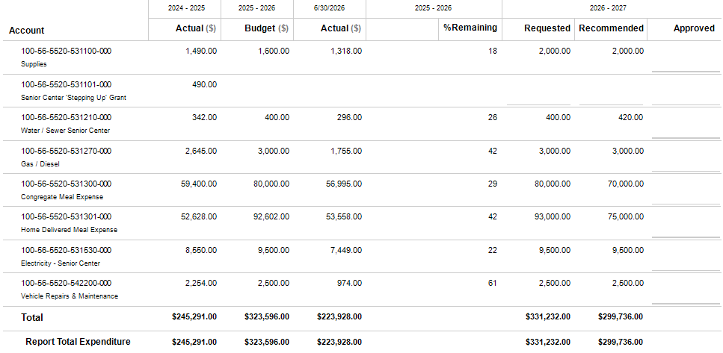

Sheriff’s Office
DEPARTMENT PROFILE
The Sheriff is a county constitutional officer and is elected by the voters for four-year terms. This elected office is composed of eight divisions: Uniform patrol, Criminal Investigations, Canine Division, Traffic Division, School Resource, Court Services, Civil and Warrants Division, and E-911. The Sheriff and his staff enforce all federal, state and local laws enacted for the protection of life, property, health, safety and welfare of all residents and citizens who reside and visit. This office provides courthouse security including all courts, processes warrants, and civil papers and all writs including evictions and court ordered transports and currently operates a 32-bed county jail.
STAFFING PLAN
Position Title | FY 24-25 | FY 25-26 | FY 26-27
Sheriff | 1 | 1 | 1
Administrative Assistant (Major) | 1 | 1 | 1
Administrative Assistant | 2 | 2 | 2
Road Supervisor (Major) | 1 | 1 | 1
CID | 3 | 3 | 3
Deputy | 15 | 17 | 19
School Resource Officer (SRO) | 4 | 5 | 5
Total Positions | 27 | 30 | 32

BUDGET HIGHLIGHTS
- Requesting 2 new deputy positions totaling $102,319.36 plus benefits and additional supplies and uniforms to outfit.

- Contract Services increased for additional Flock Safety cameras now totaling $67,900 and a new software and system to aid in investigations at $14,978.
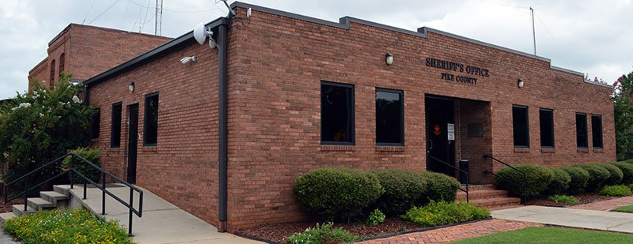

Sheriff’s Office – Detail
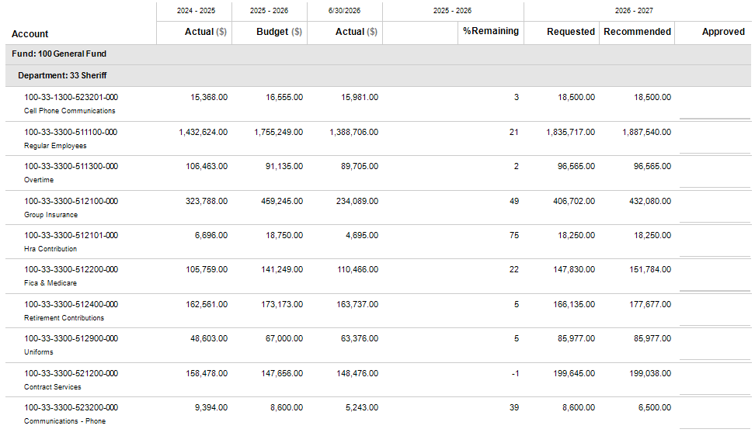
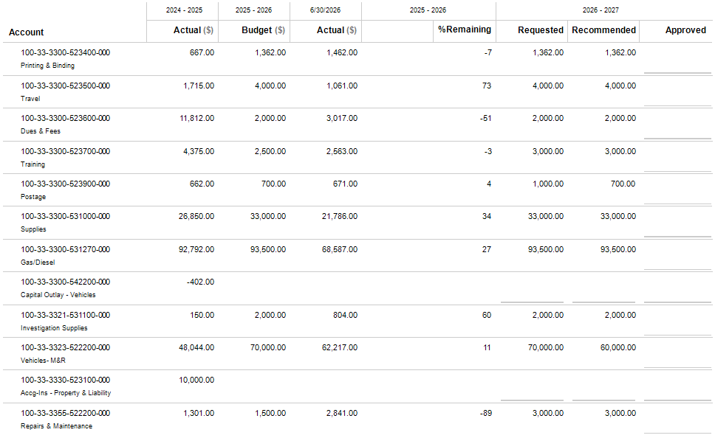
Sheriff’s Office – Detail Continued

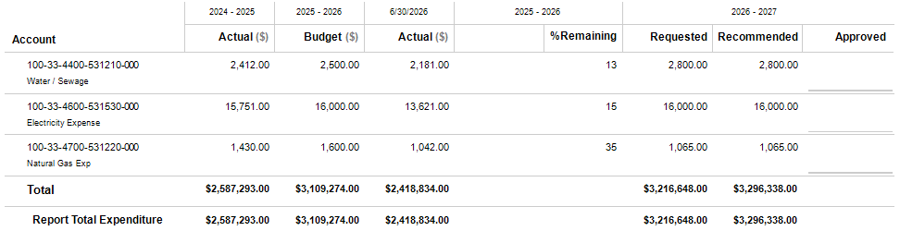
Sheriff’s Office – Detail Continued

Solid Waste
DEPARTMENT PROFILE
Pike County contracts with Harbin Engineering to monitor nine wells that are located on the decommissioned landfill. These wells are monitored for contamination to ensure that any potentially hazardous waste is contained to the site and is not allowed to enter the ground water. In addition, Harbin Engineering helps the county with submitting EPD reports and applying for grants to help fund the monitoring and upkeep of the site.
In addition, Pike County contracts with Amwaste for leasing and operating the transfer station from the county for $10,000 per year.
STAFFING PLAN
Position Title | FY 24-25 | FY 25-26 | FY 26-27
No Positions in this Department | 0 | 0 | 0
Total Positions | 0 | 0 | 0

BUDGET HIGHLIGHTS
- AmWaste contract was renewed on April 1, 2026, for an additional year starting July 1, 2026.

- Contract services were increased $168,000 to cover additional landfill remediation and monitoring potentially required by EPD. This amount would be funded by a reimbursement from the Hazardous Waste Trust Fund.

Solid Waste - Detail
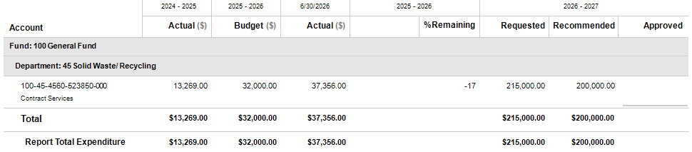

Tax Assessor
DEPARTMENT PROFILE
The five-member Board of Tax Assessors is appointed by the Board of Commissioners for six-year terms. The Board of Tax Assessors hires a Chief Appraiser to run the day-to-day operations of the department. The Chief Appraiser and his staff determines what property in the county is subject to taxation, prepares annual property tax assessments, prepares the annual tax digest, examines and corrects errors in all real and personal property tax returns, and ensures that all property is returned for taxes at fair valuations and that the valuations between individual taxpayers are fairly equalized so that each pays as nearly as possible only his or her proportionate share of taxes. In addition, this department also hears taxpayer appeals regarding property tax valuations, maintains county tax records and maps of greater than 10,000 taxable and exempt real property parcels, 2,800 personal property accounts, and inspects 1,150 mobile homes for value. Lastly, this department compiles building costs, adheres to policies set by the Georgia Department of Revenue, and provides staff support to the Board of Tax Assessors.
STAFFING PLAN
Position Title | FY 24-25 | FY 25-26 | FY 26-27
Board Member (Appointed) | 5 | 5 | 5
Chief Appraiser | 1 | 1 | 1
Appraiser | 5 | 5 | 4
Total Positions | 11 | 11 | 10

BUDGET HIGHLIGHTS
- An appraiser position became vacant during FY25-26 and was not replaced for the FY26-27 budget.

- Increase in Contract Services for Norman Appraisal Services to finish up their commercial contract and also begin work on a subdivisions contract.

Tax Assessor – Detail
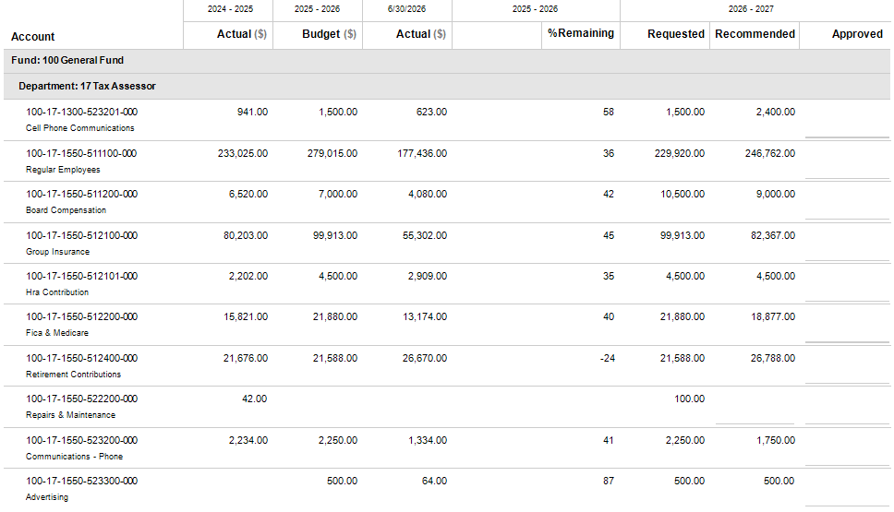
Tax Assessor – Detail Continued
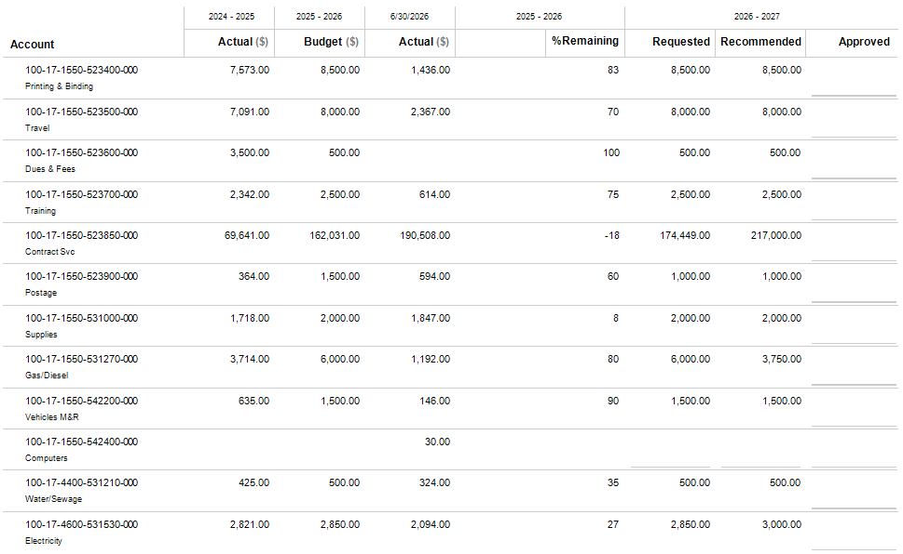
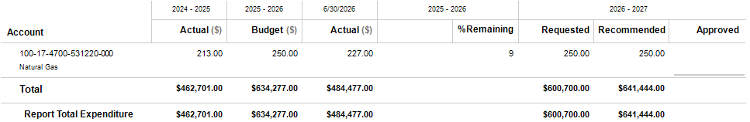
Tax Assessor – Detail Continued

Tax Commissioner
DEPARTMENT PROFILE
The Tax Commissioner is elected by the voters for four-year terms. The Tax Commissioner is responsible for collecting all County, Board of Education, and state property taxes as well as motor vehicle taxes. In addition, this office collects property taxes for the cities of Zebulon and Williamson. The Tax Commissioner mails approximately 13,000 real and personal property tax bills, 243 mobile home tax bills, and 31,500 motor vehicle registrations. This elected official also issues executions against delinquent taxpayers, sells motor vehicle license plates, transfers vehicle titles, collects motor vehicle annual ad valorem & mobile home taxes for the municipalities, timber taxes, and issues mobile home decals. In addition, the Tax Commissioner also serves as the ex-officio sheriff where she processes non-judicial sales for taxes owed.
STAFFING PLAN
Position Title | FY 24-25 | FY 25-26 | FY 26-27
Tax Commissioner | 1 | 1 | 1
Clerk (Part-Time) | 1 | 1 | 1
Clerk (Full-Time) | 3 | 3 | 3
Total Positions | 5 | 5 | 5

BUDGET HIGHLIGHTS
- Increases from prior year relate to part-time position hours change, insurance and retirement contributions

- As of late April 2026, the Georgia Senate passed SB 33, a major homestead property tax overhaul that caps annual assessment growth at 3%. The bill removes the opt-out provision that was allowed under HB 581 but allows the addition of an LHOST (Local Homestead Option Sales Tax) to recapture a portion of the lost revenues. The maximum allowable county sales tax percentage will be 9%.
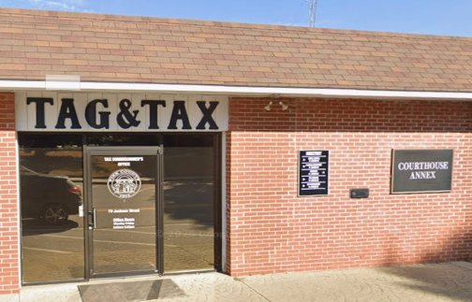
Tax Commissioner – Detail
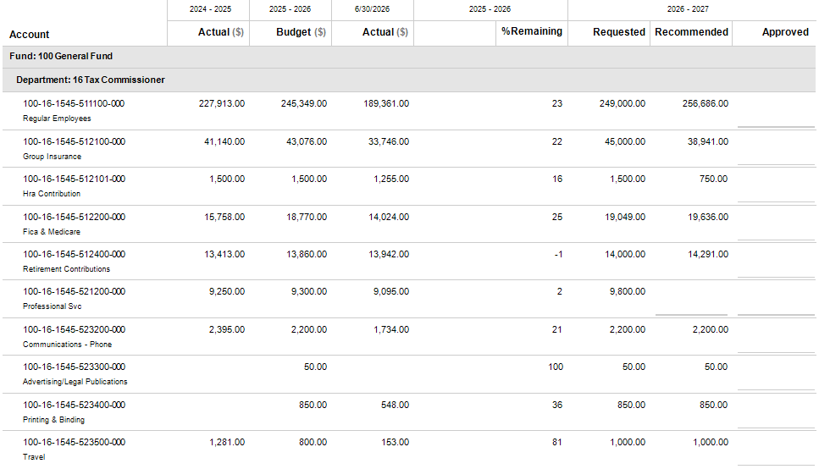
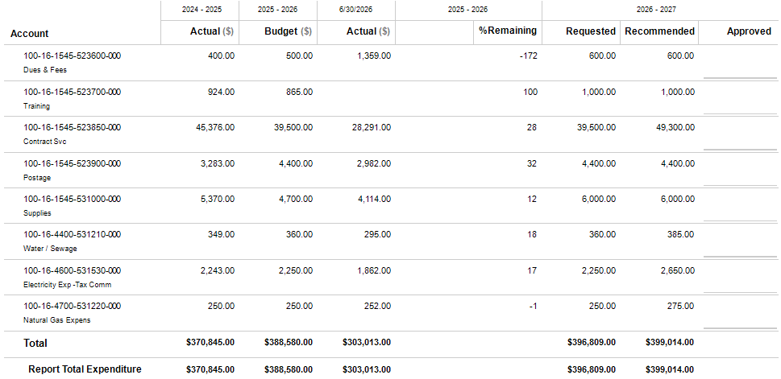
Tax Commissioner – Detail Continued

General Fund Transfers
- $203,700 Transfer out of General Fund to LMIG to cover the county match requirements

- $361,372 Transfer out of General Fund to CAIP to cover capital improvements in various departments

- $795,125 Transfer out of General Fund to E911 to supplement the cost of E911 operations that is not covered by the revenues charged to phone lines
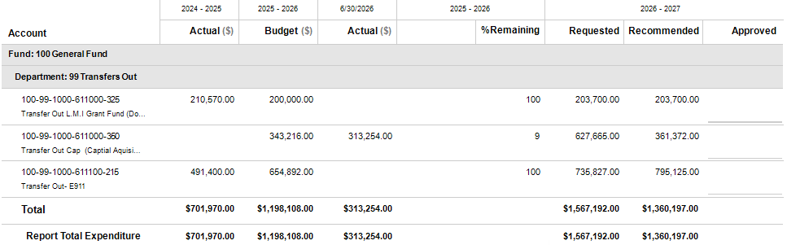

Outside Agencies

AGENCY PROFILES
The Pike County Board of Commissioners funds 11 agencies that are outside the structure of Pike County government operations. The county considers these 11 agencies essential to the county residents, and therefore, partly funds their annual operations.

Agribusiness Authority
The Pike County Agri-Business Authority was created in 1995 with five appointed board members to encompass many duties, including educational programs related to farm and domestic animals and livestock and for the exhibition of Pike County Agriculture and Agribusiness. The Agri-Business Authority may be involved in many projects and programs to promote agriculture in Pike County. This Authority is funded through Grants, the Board of Commissioners, and revenues they collect from the operation of Chestnut Oaks Facility and events.
BUDGET HIGHLIGHTS
- FY26-27 will be the first year of a 20 year payback to the county for the cost of the Chestnut Oaks facility.

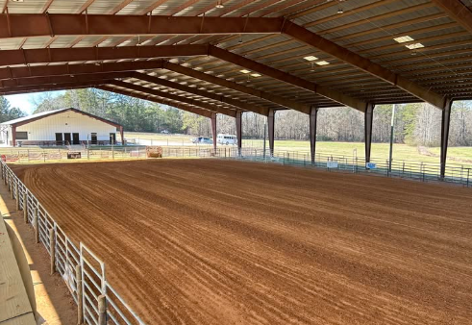

Outside Agencies – Agribusiness Authority
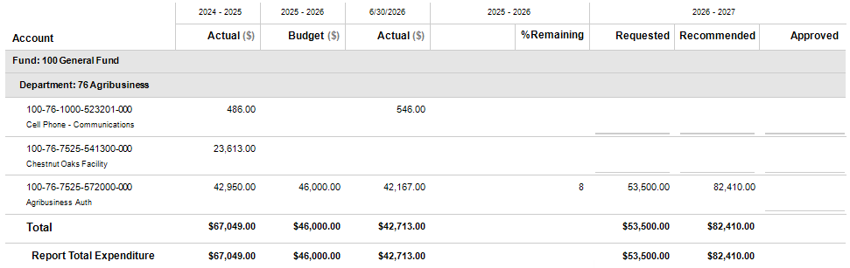

Outside Agencies

AGENCY PROFILES
The Pike County Board of Commissioners funds 11 agencies that are outside the structure of Pike County government operations. The county considers these 11 agencies essential to the county residents, and therefore, partly funds their annual operations.

Ambulance Contract
In June of 2022 Pike County renewed their contract with AmeriPro EMS. This contract will automatically renew each year not to exceed five renewals through June 30, 2027. AmeriPro is responsible for providing two ambulances, twenty-four hours a day, seven days a week, 365 days a year, dedicated to 911 calls for emergency. The county uses the Commission on Accreditation for Ambulance Services Standards and the National Fire & Protection Administration Standard for response times of 8 minutes and 59 seconds for all life-threatening emergency responses three miles or less from the staging location. All calls over three miles and non-life-threatening emergency responses will have a standard response time of less than 12 minutes. Each ambulance will be staffed with a minimum of one Paramedic level EMS provider and one other EMS provider. The cost for this service to the County will be $68,500 per month beginning 6/10/2022, and the annual subsidy increase will only be 3% per year on the anniversary date of the agreement.
BUDGET HIGHLIGHTS
- The 3% annually contracted increase will total ambulance services at $925,169 for FY26-27.

Outside Agencies – Ambulance Contract
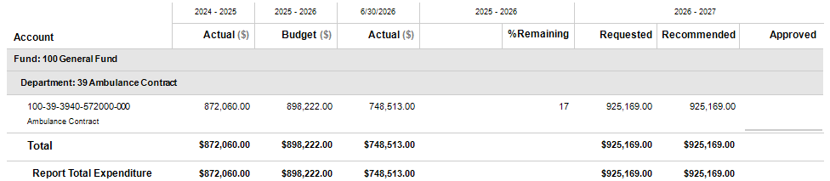

Outside Agencies

AGENCY PROFILES
The Pike County Board of Commissioners funds 11 agencies that are outside the structure of Pike County government operations. The county considers these 11 agencies essential to the county residents, and therefore, partly funds their annual operations.

Community Services
Pike County appoints 1 member of the regional community services board which serves Butts, Fayette, Henrey, Lamar, Pike, Spalding, and Upson. This board acts in accordance with O.C.G.A. 37-2-6. Members serve a 3-year term. This board serves to address issues in the administration of mental health, developmental disabilities, addictive diseases, and other disability services.





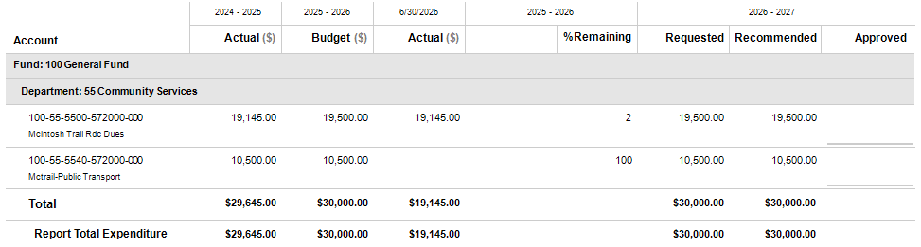
Outside Agencies – Community Services

Outside Agencies

AGENCY PROFILES
The Pike County Board of Commissioners funds 11 agencies that are outside the structure of Pike County government operations. The county considers these 11 agencies essential to the county residents, and therefore, partly funds their annual operations.

County Agent (EXTENSION SERVICES)
This department, under the direction of the University of Georgia Cooperative Extension, distributes updated agricultural research material to local agricultural producers, farmers, and homeowners. This department has three program areas: Agriculture & Natural Resources, Family & Consumer Sciences, and 4-H Youth Development. The Agriculture & Natural Resources program provides soil, water, and forage testing, insect identification, plant disease diagnostics, and educational workshops on lawns, pastures, vegetables, sustainable agriculture, and livestock. The Family & Consumer Sciences program deals with all aspects of the economics and management of the home and community including nutrition, food preparation, parenting, early childhood education, and family economics. The 4-H Youth Development program assists 4th-12th graders in acquiring knowledge, developing life skills, and forming attitudes that will enable them to become self-directing, productive, and contributing members of society.
STAFFING PLAN
Position Title | FY 24-25 | FY 25-26 | FY 26-27
County Agent | 1 | 1 | 1
Administrative Assistant | 1 | 1 | 1
4-H Youth Coordinator | 1 | 1 | 1
Total Positions | 3 | 3 | 3

BUDGET HIGHLIGHTS
- All positions are now paid through the contract services account. (County Agent and Administrative Assistant: ≈ 33% BOC / 67% UGA) (4-H Youth Coordinator: 100% County)

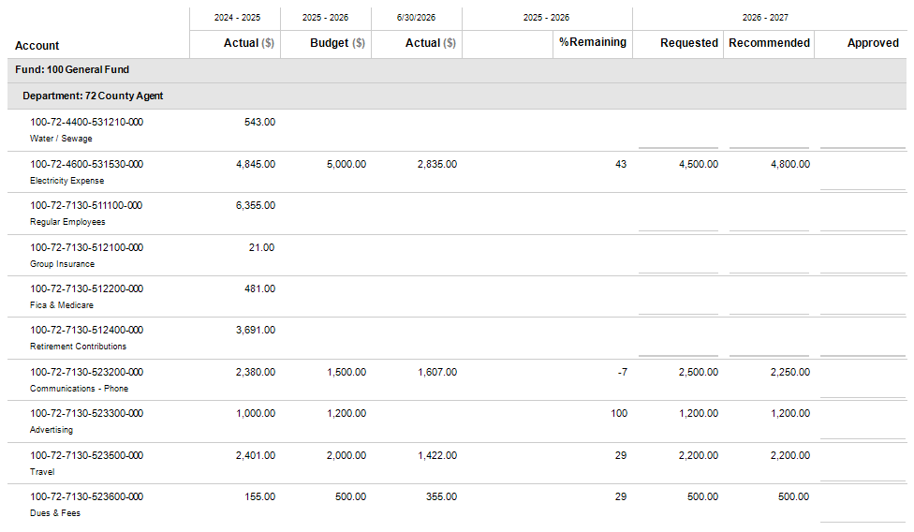
Outside Agencies – County Agent (Ext. Services)

Outside Agencies – County Agent (Ext. Services) - Continued
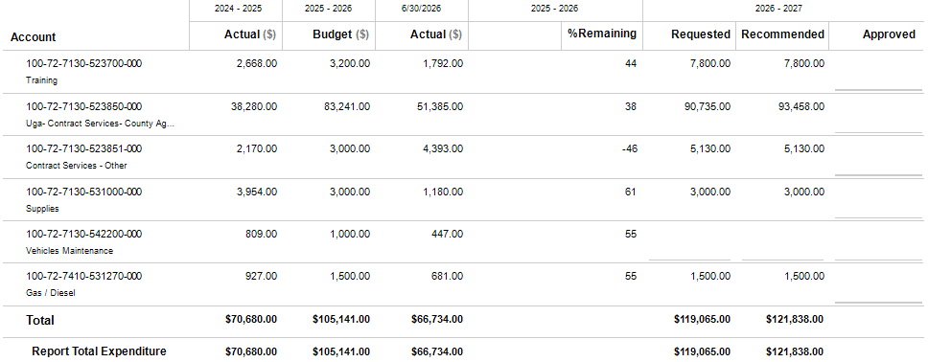

Outside Agencies

AGENCY PROFILES
The Pike County Board of Commissioners funds 11 agencies that are outside the structure of Pike County government operations. The county considers these 11 agencies essential to the county residents, and therefore, partly funds their annual operations.

Development Authority of Pike County
The seven-member board, which was later updated to a ten-member board to include the Chairman of the Board of Commissioners, Mayor of Zebulon, and Superintendent of Schools is a created development authority created to promote trade, commerce, industry, and employment opportunities for the public good and general welfare of Pike County. Each of these members serves a four-year term. This authority acts in accordance with the Georgia Development Authorities Law, O.C.G.A. 36-62-1. The Authority is responsible for marketing and developing the county’s two industrial business parks, the Zebulon Business Park, and the Hwy 41 Business Park.
STAFFING PLAN
Position Title | FY 24-25 | FY 25-26 | FY 26-27
Executive Director | 1 | 1 | 1
Total Positions | 1 | 1 | 1

BUDGET HIGHLIGHTS
- The Development Authority’s current millage rate is set at 0.25.

- The County will budget for both revenues and expenditures to help keep costs of the authority as low as possible and offer a competitive benefits package for help in retaining qualified employees. The County will be reimbursed monthly by the Development Authority for expenditures the county incurs. Those budget lines are:
  - Regular Employees
  - Group Insurance
  - FICA/Medicare
  - Retirement Contributions
  - Cell Phone – Communications
  - Contract Services

Outside Agencies – Development Authority of Pike County
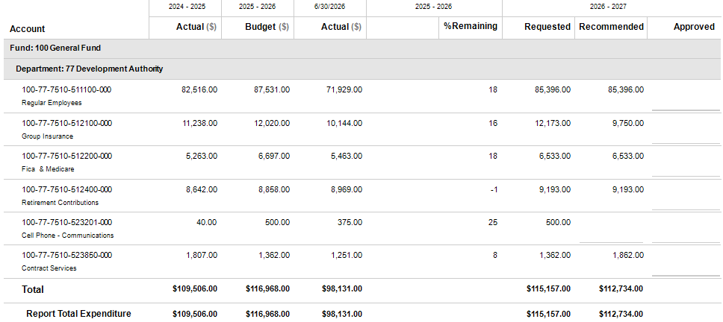

Outside Agencies

AGENCY PROFILES
The Pike County Board of Commissioners funds 11 agencies that are outside the structure of Pike County government operations. The county considers these 11 agencies essential to the county residents, and therefore, partly funds their annual operations.

Forestry
Pike County provides supplemental funding to the Georgia Forestry Commission to assist the county in forest management and conservation, fire prevention and suppression, and educational benefits.
BUDGET HIGHLIGHTS
- No significant changes from the previous fiscal year.



Outside Agencies – Forestry
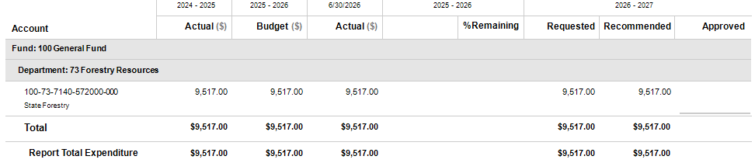

Outside Agencies

AGENCY PROFILES
The Pike County Board of Commissioners funds 11 agencies that are outside the structure of Pike County government operations. The county considers these 11 agencies essential to the county residents, and therefore, partly funds their annual operations.

Georgia Division of Family and Children Services (DFACS)
This state agency, under the direction of the Georgia Department of Human Services Region 4, provides and administers all welfare and public assistance functions for the county including such programs as temporary assistance to needy families (TANF), adult Medicaid, food stamps, employment services, child protective social services, foster care, and adoptions. The county provides this agency with an annual supplement.
BUDGET HIGHLIGHTS
- No significant changes from the previous fiscal year.



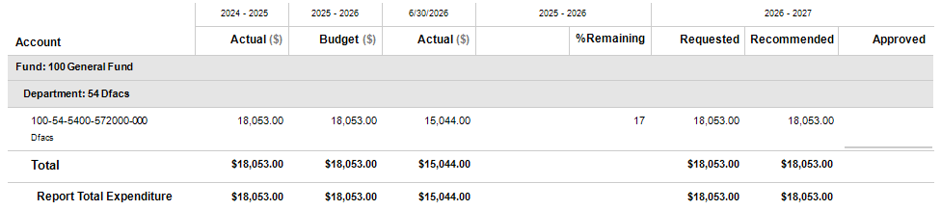
Outside Agencies – DFACS

Outside Agencies

AGENCY PROFILES
The Pike County Board of Commissioners funds 11 agencies that are outside the structure of Pike County government operations. The county considers these 11 agencies essential to the county residents, and therefore, partly funds their annual operations.

Health Department
This state agency, under the direction of the local Board of Health, determines the county’s health needs and develops programs to meet those needs. This agency administers numerous community health related programs such as children and adult immunizations, hearing, vision, and dental screenings, STD screenings and treatment, TB detection and treatment, tobacco use prevention, teen clinic, women’s health programs, emergency preparedness, WIC program, and maintains vital records including birth and death certificates. In addition, this agency has an environmental health unit that reviews plans and inspects tourist accommodations, inspects cleanliness of restaurants, inspects public swimming pools, evaluates, and protects private water wells, issues septic tank permits, performs rabies control activities, investigates health and disease related issues, and performs various public education activities. The county provides this agency with a county-owned building and an annual supplement.
BUDGET HIGHLIGHTS
- Two years ago the Health Dept. assigned Ben Trotter full-time to Pike County and this is currently being funded by a State Grant that is set to expire in November 2027 or FY27-28. The Health Dept. is requesting the county begin to cover a part of the expenditures incurred by this move that was originally shared between Upson, Pike and the State. The cost that will need to be covered by the County fully in FY27-28 is currently $66,902.

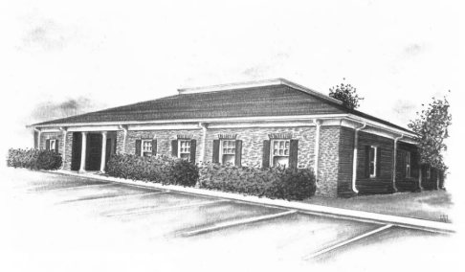

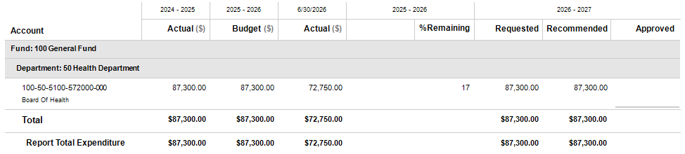
Outside Agencies – Health Department

Outside Agencies

AGENCY PROFILES
The Pike County Board of Commissioners funds 11 agencies that are outside the structure of Pike County government operations. The county considers these 11 agencies essential to the county residents, and therefore, partly funds their annual operations.

Pike County Public Library
The Pike County Public Library offers a full range of library services to all citizens of the county to meet the citizens’ informational, educational, and recreational needs. As a part of the Flint River Regional Library system of nine libraries (Barnesville-Lamar, Fayette, Griffin-Spalding, Jackson-Butts, Milner, Monroe, Peachtree City, Pike and Tyrone). The system is headquartered in Griffin. The library is a member of the Public Information Network for Electronic Services (PINES) to increase the community’s access to information.
STAFFING PLAN
Position Title | FY 24-25 | FY 25-26 | FY 26-27
Manager | 1 | 1 | 1
Assistant Manager | 1 | 1 | 1
Librarian | 3 | 3 | 3
Total Positions | 5 | 5 | 5

BUDGET HIGHLIGHTS
- No significant changes from the previous fiscal year.



Outside Agencies – Library
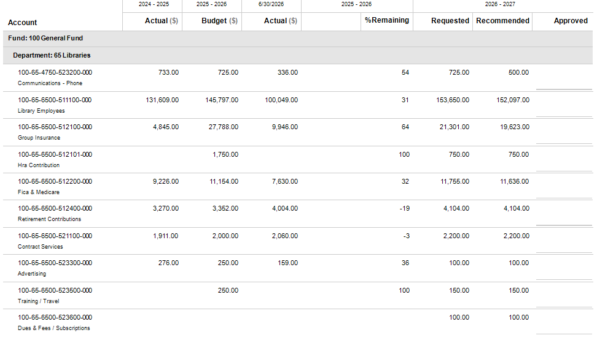
Outside Agencies – Library Continued
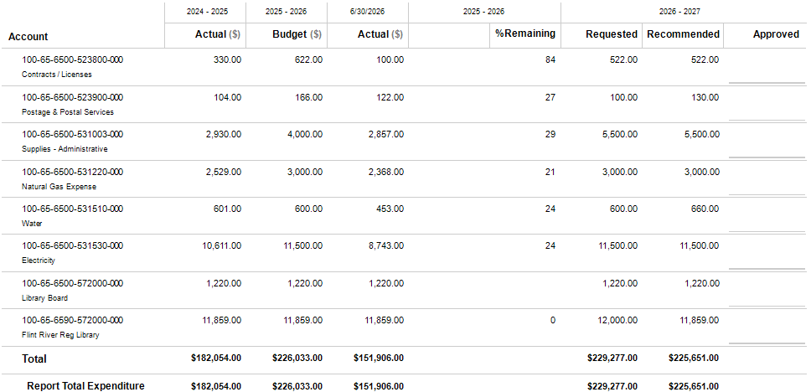

Outside Agencies

AGENCY PROFILES
The Pike County Board of Commissioners funds 11 agencies that are outside the structure of Pike County government operations. The county considers these 11 agencies essential to the county residents, and therefore, partly funds their annual operations.

Pike County Parks and Recreation Authority
The Pike County Parks and Recreation Authority (PCPRA) provides county-wide recreational programming to all citizens of the county. This department manages the Community Center. The 93-acre park consists of ten lighted ballfields, a lighted football field, two concession stands, two pavilions, playground, and gravel parking. The department offers numerous organized youth recreational programs through community associations including baseball/softball, football, basketball, soccer, cheerleading and camps using both county and Board of Education facilities.
STAFFING PLAN
Position Title | FY 24-25 | FY 25-26 | FY 26-27
Director | 1 | 1 | 1
Assistant Director | 1 | 1 | 1
Administrative Assistant | 1 | 1 | 1
Park Maintenance Tech | 4 | 4 | 4
Total Positions | 7 | 7 | 7

BUDGET HIGHLIGHTS
- Increases from prior year relate to insurance and retirement contributions.

- The $1,500,000 Georgia Outdoor Stewardship Program grant for the Pike County Parks and Recreation Authority project will include the acquisition of 35 acres of woodland adjacent to the County’s sports recreation complex. This proposal will create nature-based recreation opportunities on a parcel that is currently inaccessible to park visitors and will include construction of a primitive hike-in campground, disc golf course, development of approximately 1 mile of soft surface trail and bridge, addition of a fishing dock and bird blind. A lighted parking lot, trail amenities, and educational signage will be installed. The project will also include removal of invasive species and replanting the area along the stream buffer with native plants to create wildlife habitat, and stabilization of a section of the streambank to prevent erosion.

Outside Agencies – PCPRA
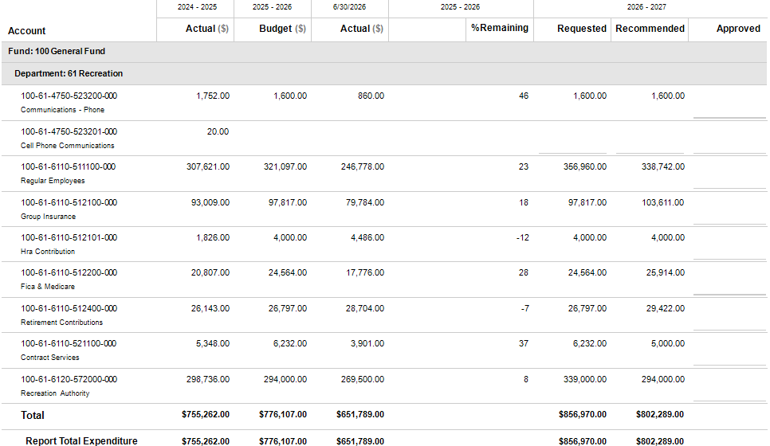

Outside Agencies

AGENCY PROFILES
The Pike County Board of Commissioners funds 11 agencies that are outside the structure of Pike County government operations. The county considers these 11 agencies essential to the county residents, and therefore, partly funds their annual operations.

Pike County Water and Sewerage Authority
The Pike County Water & Sewerage Authority (PCWSA) was created for the purpose of providing the best possible public drinking water to the citizens of Pike County. The treatment for sewage water involves several steps to remove all the contaminants, such as waste products, chemicals, or other contaminants. The Water and Sewerage Board consists of 5 members who are appointed by the Board of Commissioners for 5-year terms.

BUDGET HIGHLIGHTS
- The customer base continues to increase and the Authority will now fund several operating expenditures formally paid for by the county.

Outside Agencies – PCWSA
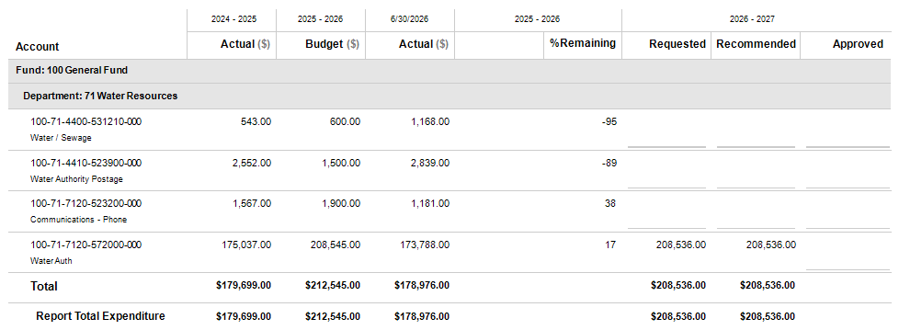

Special Revenue Funds
Special Revenue Funds are used to account for all financial resources that are legally or administratively restricted for special purposes. The county has eleven Special Revenue Funds: ARPA Fund, Drug Abuse Treatment & Education Fund, E911 Fund, Federal Seizure Fund, Hotel/Motel Tax Fund, Impact Fee Fund, Jail Construction Fund, Juvenile Court Fund, Law Library Fund, Opioid Abatement Fund and Probate Court Technology Fee Fund.



ARPA Fund
FUND PROFILE
This Special Revenue Fund is used to account for federal grant funds received from the American Rescue Plan Act (ARPA). The ARPA grant funds were originally restricted to be used for support of the public health response, address negative economic impacts, premium pay for essential workers, payroll expenses for public health and public safety employees, replace public sector revenue loss, water and sewer infrastructure, and broadband. The Board of Commissioners originally voted to spend the $3,683,146 on several projects. $1,000,000 was to be set aside and to be spent on future broadband projects, and the remaining $2,683,146 was to be spent on expanding the water infrastructure in Pike. On May 10th, 2023, the Board of Commissioners voted to keep the previously discussed projects, but to claim the entire $3,683,146 as loss of revenues so that the funds would no longer be so deeply restricted by Federal Guidelines and could be spent on any general governmental purpose. Funds were still required to be incurred/obligated by Dec 2024 and fully expended by Dec 2026.
STAFFING PLAN
Position Title | FY 24-25 | FY 25-26 | FY 26-27
No Positions in this Department | 0 | 0 | 0
Total Positions | 0 | 0 | 0

BUDGET HIGHLIGHTS
- ARPA Expenditures Breakdown through 4/20/2026

ARPA Funds Available $3,683,146
Master Planning & Other Professional Services (13,209)
Development of Website (3,438)
Digital Aerial Mapping (33,963)
County Road Projects (1,313,176)
Capital Vehicles and Equipment (161,120)
PCWSA Infrastructure Projects (428,448)

Funds Encumbered But Not Spent as of 5/19/2026 $1,729,792
County Road Projects (58,080)
PCWSA Infrastructure Projects (1,671,712)

Total $ ---- 0 ----

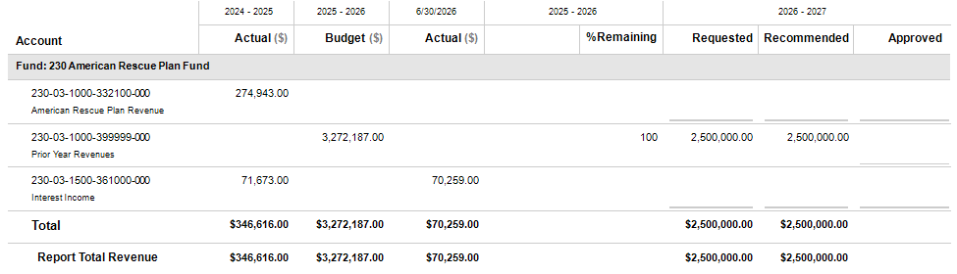
ARPA Fund – Detail Revenues

ARPA Fund – Detail Expenditures
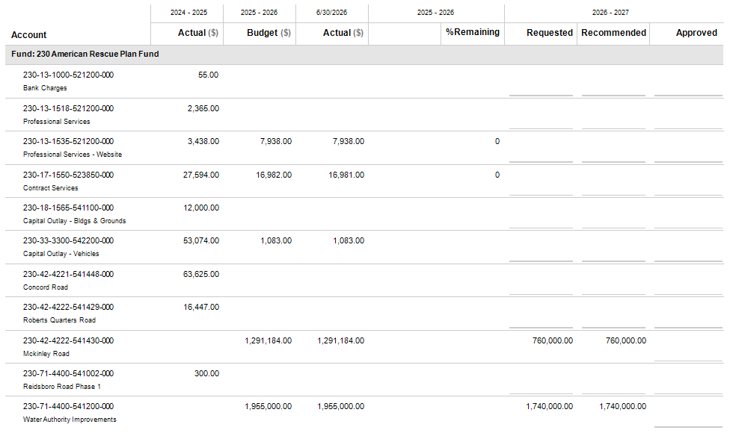

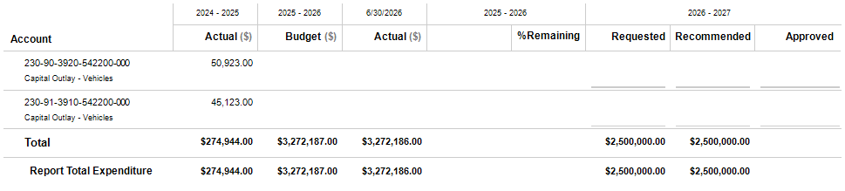
ARPA Fund – Detail Expenditures Continued

Drug Abuse Treatment & Education Fund
FUND PROFILE
This Special Revenue Fund, authorized by O.C.G.A. 15-21-100 to 15-21-101, is used to account for an additional 50% penalty placed on certain drug-related fines collected in Superior Court, Magistrate Court, and Probate Court. These funds are legally restricted to be used for drug abuse treatment and education programs relating to controlled substances, alcohol, and marijuana.
STAFFING PLAN
Position Title | FY 24-25 | FY 25-26 | FY 26-27
No Positions in this Department | 0 | 0 | 0
Total Positions | 0 | 0 | 0

BUDGET HIGHLIGHTS
- No significant changes from the previous fiscal year.

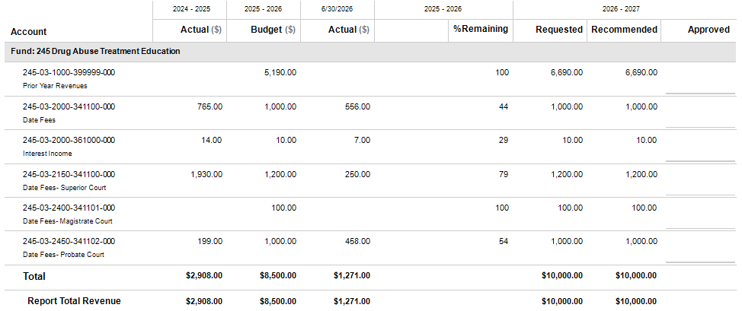
DATE Fund – Detail Revenues

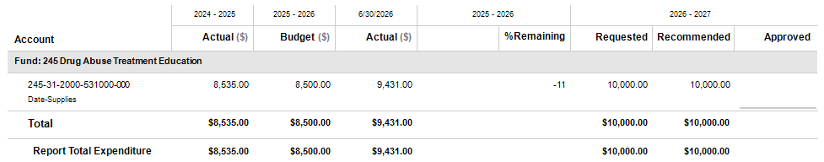
DATE Fund – Detail Expenditures

E911 Fund
FUND PROFILE
This Special Revenue Fund, authorized by O.C.G.A. 46-5-133 to 46-5-134, is used to account for the revenues collected from a monthly $1.50 surcharge placed on all landline telephones, a monthly $1.50 surcharge placed on all wireless telephones (Phase I and II), a monthly $1.50 surcharge placed on all VoIP telephones, and a $1.50 surcharge placed on prepaid wireless devices. These funds are legally restricted to be used to operate the county-wide 911 emergency telephone system. This department’s certified communication officers receive and process emergency and non-emergency telephone calls on a county-wide basis and dispatches emergency personnel from the Sheriff’s Office, Zebulon, and Molena police departments, county-wide EMS, two fire departments, and assists many other county departments and state agencies with their various communication needs. This department also maintains the county-wide Master Street Address Guide (MSAG).
STAFFING PLAN
Position Title | FY 24-25 | FY 25-26 | FY 26-27
Supervisor | 1 | 1 | 1
Shift Supervisor | 3 | 3 | 3
Dispatcher | 8 | 8 | 8
Total Positions | 12 | 12 | 12

BUDGET HIGHLIGHTS
- Increases from prior year relate to insurance and retirement contributions.

- Various hardware/equipment refresh leases are being renewed through AT&T Capital for a five year term. These leases are budgeted at $90,000 (principal) and $14,000 (interest) for FY26-27.

- $795,465 is needed from the General Fund to balance this budget.

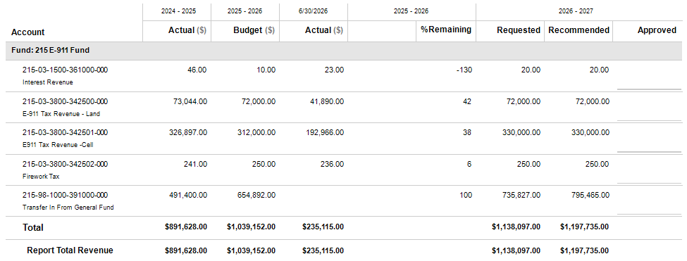
E911 Fund – Detail Revenues

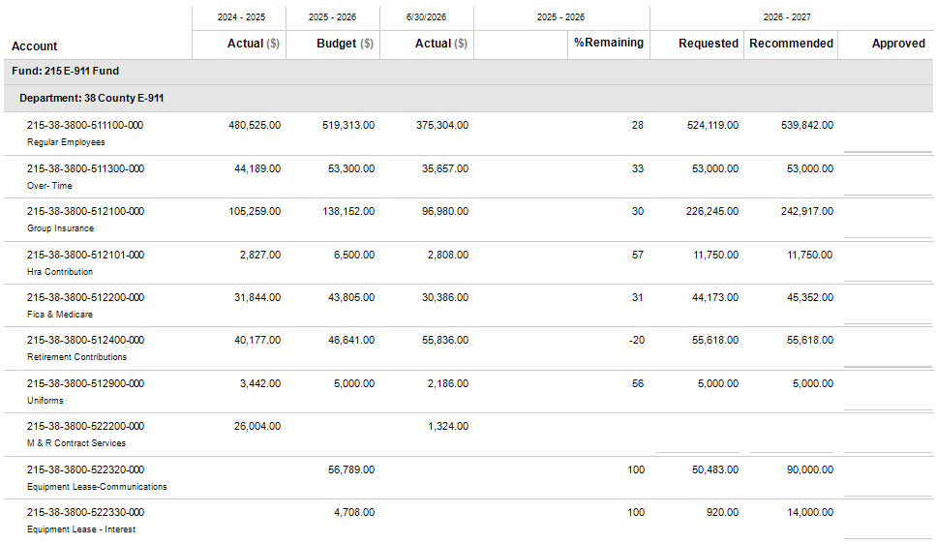
E911 Fund – Detail Expenditures

E911 Fund – Detail Expenditures Continued
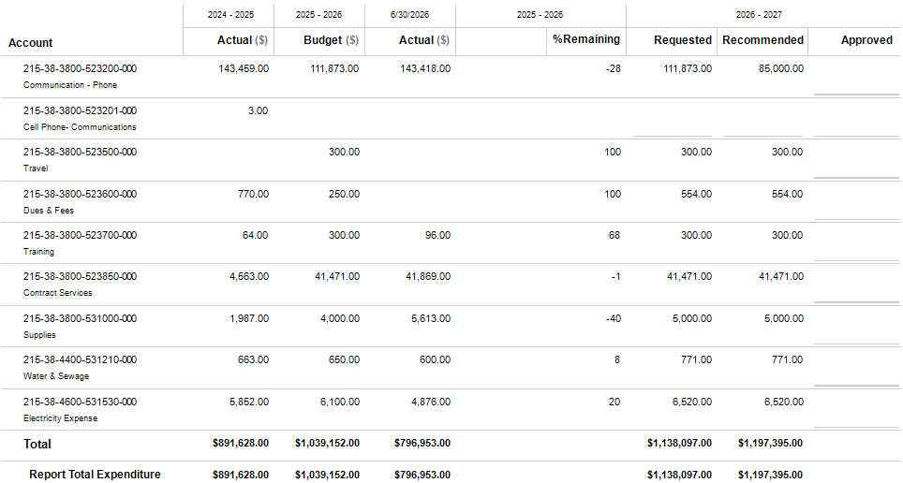

Federal Seizure Fund
FUND PROFILE
This Special Revenue Fund, authorized by O.C.G.A. 16-13-49 and under the direction of the elected Sheriff, is used to account for revenues generated from confiscated items. These funds are legally restricted to be used for any official law enforcement purpose except for the payment of salaries or rewards to law enforcement personnel.
STAFFING PLAN
Position Title | FY 24-25 | FY 25-26 | FY 26-27
No Positions in this Department | 0 | 0 | 0
Total Positions | 0 | 0 | 0

BUDGET HIGHLIGHTS
- No significant changes from the previous fiscal year.

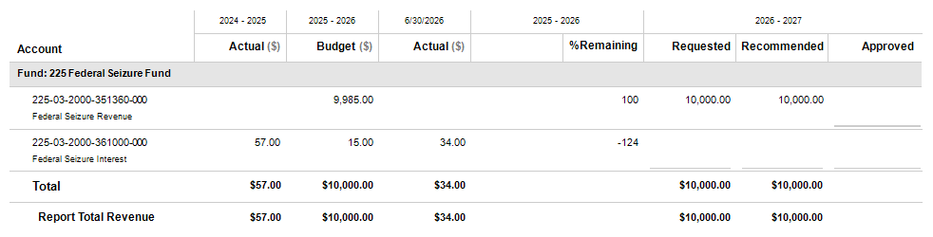
Federal Seizure Fund – Detail Revenues

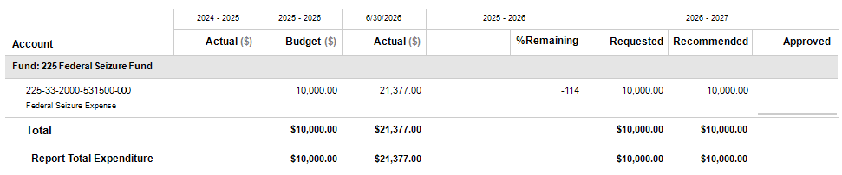
Federal Seizure Fund – Detail Expenditures

Hotel/Motel Tax Fund
FUND PROFILE
This Special Revenue Fund, authorized by O.C.G.A. 48-13-51 is used to account for the proceeds of the 5% hotel/motel tax collected from lodging facilities located within the unincorporated area of the county. These funds are distributed between the Development Authority (40%) and the county (60%) to be used to promote local tourism and for other purposes.
STAFFING PLAN
Position Title | FY 24-25 | FY 25-26 | FY 26-27
No Positions in this Department | 0 | 0 | 0
Total Positions | 0 | 0 | 0

BUDGET HIGHLIGHTS
- The Pike County Development Authority is the designated Destination Marketing Organization (DMO) as required by the Georgia Department of Community Affairs for the Hotel/Motel Tax reporting.

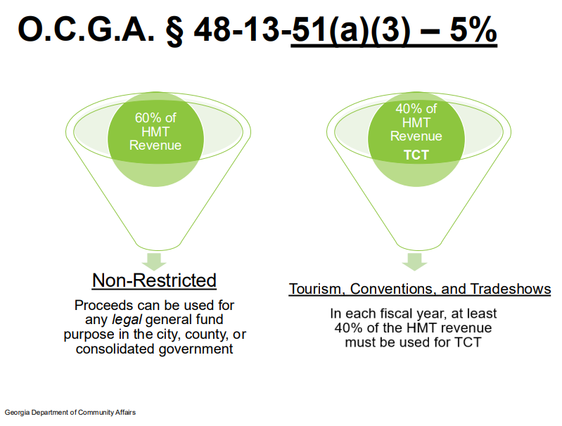

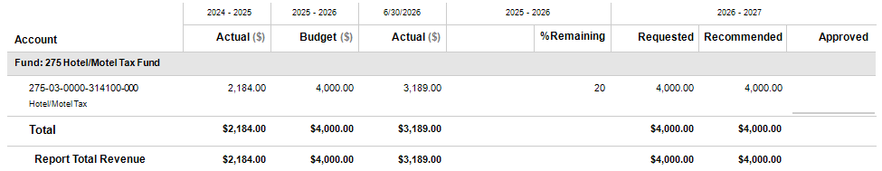
Hotel/Motel Tax Fund – Detail Revenues

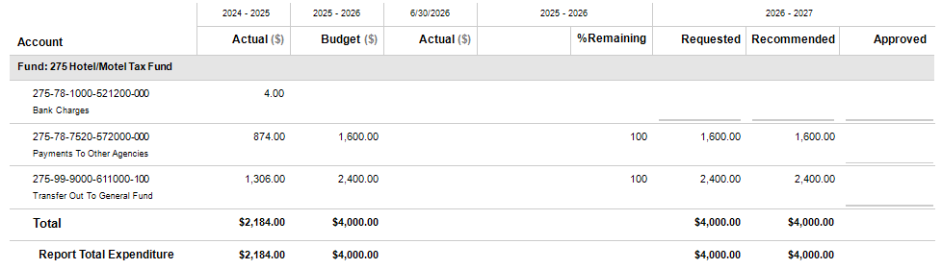
Hotel/Motel Tax Fund – Detail Expenditures

Impact Fee Fund
FUND PROFILE
On May 10, 2006, the Board of Commissioners approved the new Development Impact Fee Ordinance. This ordinance provides that adequate public facilities are available to serve new growth and development in Pike County and to provide that new growth and development bears a proportionate share of the cost of the new public facilities needed to serve them. The initial fee was set at $2,404.15 per residential dwelling and increased on January 31, 2023, to $6,775.99. On February 14, 2024, the Board of Commissioners voted to approve Ross and Associates to complete a new and updated Impact Fee Study for Pike County. The County is currently contracting with Ross and Associates to produce a new methodology report and funding updates.
STAFFING PLAN
Position Title | FY 24-25 | FY 25-26 | FY 26-27
No Positions in this Department | 0 | 0 | 0
Total Positions | 0 | 0 | 0

BUDGET HIGHLIGHTS
- Anticipated FY26-27 expenditures include projects for Next-Generation E911 equipment, Public Works Road/Bridge upgrades, PCPRA DNR grant related recreation complex upgrades and library capacity projects.

- Impact Fee Departmental Account Balances as of 04/20/2026
Sheriff …………………………………………. $179,276.08
Jail …………………………………………….. $519,469.79
Fire ……………………………………………. $450,386.71
E-911…………………………………………….$275,854.42
Roads ………………………………………….. $172,202.36
Parks …………………………………………... $124,354.96
Library ………………………………………… $134,680.54
Administration …………………………………. $45,599.57
CIE Prep ……………………………………… $7,788.78
Interest ………………………………………….. $97,815.81

Total Impact Fees $2,007,429.02

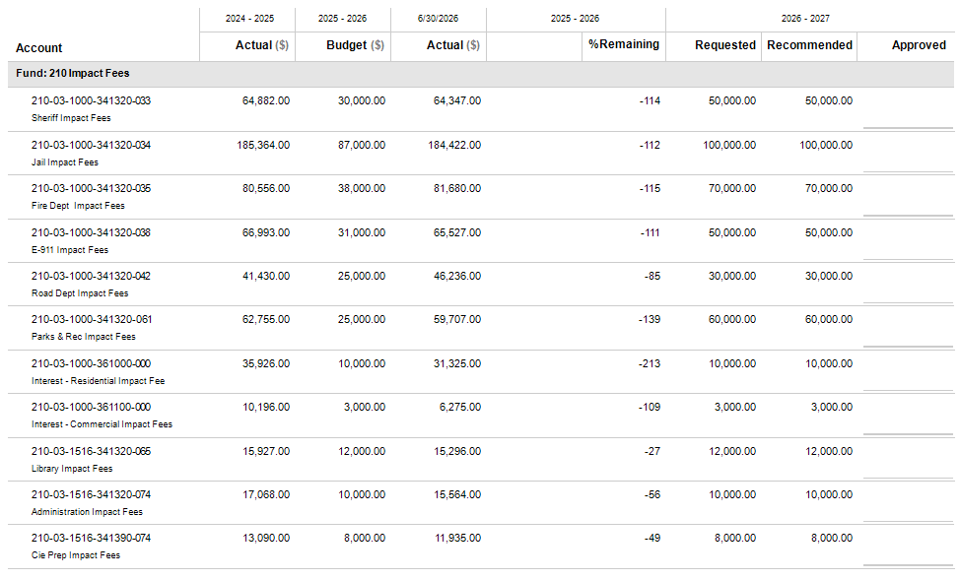
Impact Fee Fund – Detail Revenues

Impact Fee Fund – Detail Revenues Continued


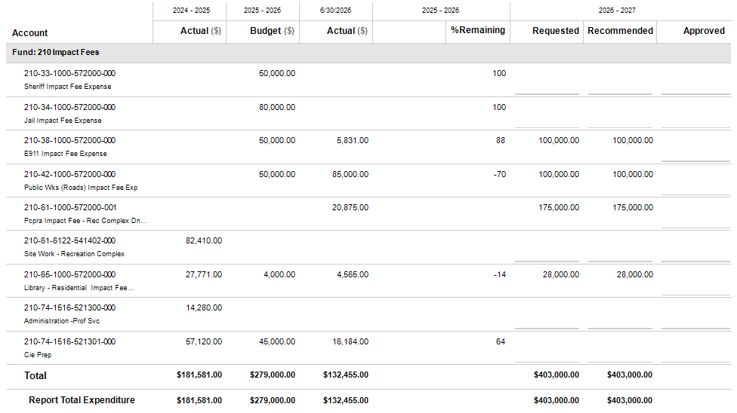
Impact Fee Fund – Detail Expenditures

Juvenile Court Fund
FUND PROFILE
This Special Revenue Fund, authorized by O.C.G.A. 15-11-37 consists of supervision fees collected from youth placed under court supervision and is used to support services that promote rehabilitation and development. These services include housing, education, counseling, mediation, transportation, truancy intervention, restitution, job training and other programs benefiting the child’s best interests. Courts may assess initial and monthly supervision fees within set ranges, with responsibility shared by the child and their guardians. Collected funds are managed by the county, deposited into a supplemental juvenile service fund and appropriated to the juvenile court for discretionary use on approved services. The funds must be used solely for these purposes, cannot replace existing funding and do not lapse at year-end. The Clerk of Superior Court is responsible for collecting all ordered fees.
STAFFING PLAN
Position Title | FY 24-25 | FY 25-26 | FY 26-27
No Positions in this Department | 0 | 0 | 0
Total Positions | 0 | 0 | 0

BUDGET HIGHLIGHTS
- No significant changes from the previous fiscal year.

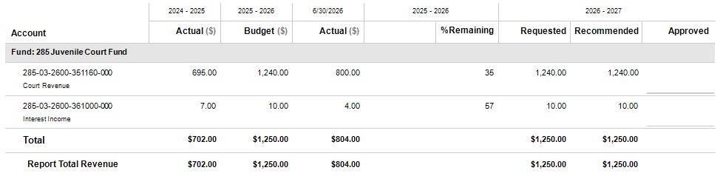
Juvenile Court Fund – Detail Revenues

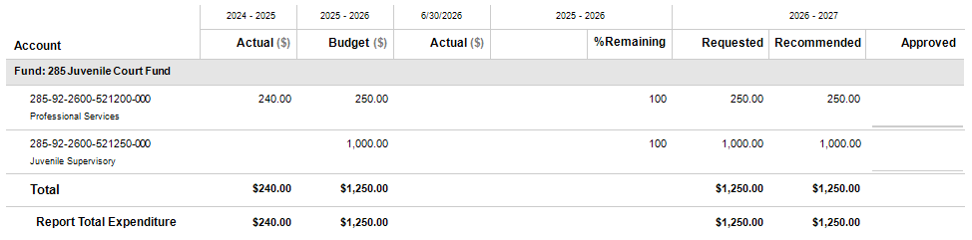
Juvenile Court Fund – Detail Expenditures

Law Library Fund
FUND PROFILE
This Special Revenue Fund, authorized by O.C.G.A. 36-15-1 to 36-15-9, is used to account for an additional sum not to exceed $5.00 placed on civil and criminal cases filed in Superior Court, Magistrate Court, Probate Court and any other courts of record. These funds are legally restricted to be used for the purchase of law books, reports, texts, periodicals, supplies, desks and equipment for the operations of the Law Library among other items. This fund has a Law Library Board of Trustees to oversee its operations.
STAFFING PLAN
Position Title | FY 24-25 | FY 25-26 | FY 26-27
No Positions in this Department | 0 | 0 | 0
Total Positions | 0 | 0 | 0

BUDGET HIGHLIGHTS
- No significant changes from the previous fiscal year.

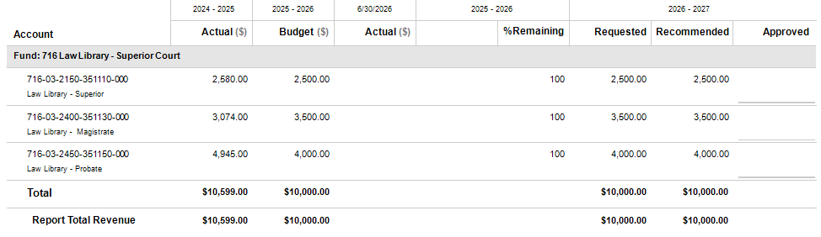
Law Library Fund – Detail Revenues

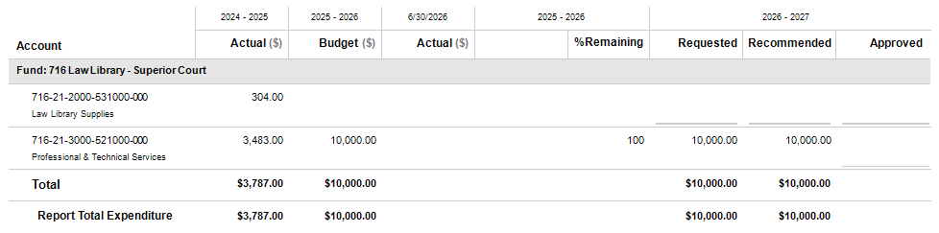
Law Library Fund – Detail Expenditures

Opioid Abatement Fund
FUND PROFILE
In January 2022, Georgia opted into opioid litigation brought by states and local subdivisions against the three largest pharmaceutical distributors - McKesson, Cardinal Health, and AmerisourceBergen - and manufacturer Janssen Pharmaceuticals, Inc. and its parent company Johnson & Johnson. The National Distributor Settlement funds will be disbursed on an 18-year plan, while the Janssen/J&J Settlement funds will be disbursed on a 9-year plan. In addition to the local funds that are received by Pike County, there are also regional funds which the county will be a part of. The county is a member of Region 6 based on the Department of Behavioral Health & Developmental Disabilities (DBHDD). Approved uses for these funds are Prevention, Treatment, Recovery, Harm Reduction, and Research & Evaluation.
STAFFING PLAN
Position Title | FY 24-25 | FY 25-26 | FY 26-27
No Positions in this Department | 0 | 0 | 0
Total Positions | 0 | 0 | 0

BUDGET HIGHLIGHTS
- No significant changes from the previous fiscal year.

- The county has chosen to partner and fund the McIntosh Trail Behavioral Health with these funds.

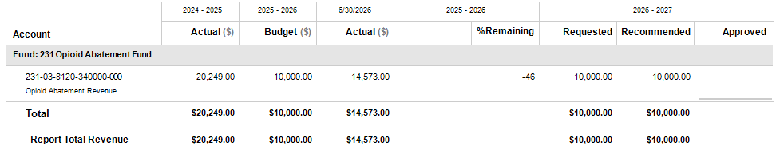
Opioid Abatement Fund – Detail Revenues

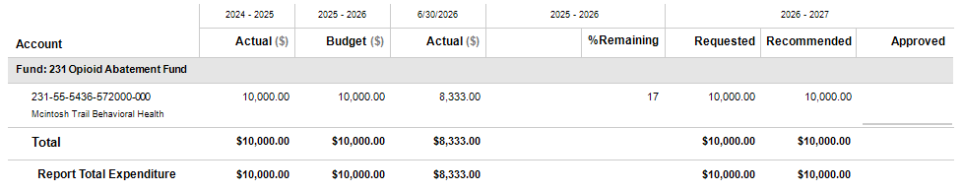
Opioid Abatement Fund – Detail Expenditures

Probate Court Technology Fee Fund
FUND PROFILE
This special revenue fund, authorized by Georgia House Bill 354 during the 2023 legislative session, is used to account for fees collected by the Probate Court for each civil action filed and surcharges for each fine paid. Such technology fund fees shall be used exclusively to provide for the technological needs of the Probate Court of Pike County. These expenditures may include hardware and software purchases, case management systems, electronic filing and records management, imaging, training, maintenance and other technology related needs that enhance court efficiency and public access. Such uses shall include only those authorized in the act, and the authority to assess the technology fee pursuant to the act shall terminate on July 1, 2033.
STAFFING PLAN
Position Title | FY 24-25 | FY 25-26 | FY 26-27
No Positions in this Department | 0 | 0 | 0
Total Positions | 0 | 0 | 0

BUDGET HIGHLIGHTS
- No significant changes from the previous fiscal year.

Probate Court Technology Fee Fund – Detail Revenues
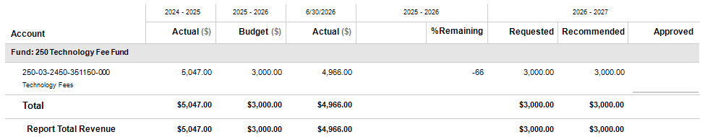

Probate Court Technology Fee Fund – Detail Expenditures
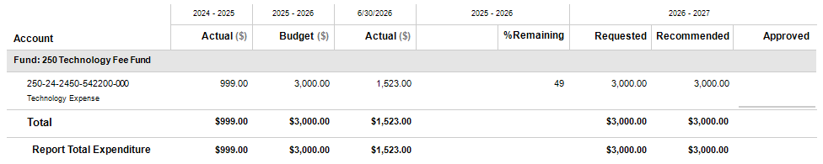

Capital Project Funds
Capital Project Funds are used to account for financial resources that are used for the acquisition of major capital assets such as buildings, infrastructure and large equipment. The county has four Capital Project Funds: SPLOST-2016 Fund, SPLOST-2022 Fund, LMIG Fund and the Capital Improvement Fund.



SPLOST-2016 Fund
FUND PROFILE
A referendum was held on March 1, 2015, to determine if the county voters wanted to continue the 1% Special Purpose Local Option Sales Tax (SPLOST) for a six-year period to raise $5,800,000 to include capital outlay projects consisting of road, street and bridge improvements and the payment of the principal and interest of previously incurred indebtedness. During the referendum, 5,002 citizens voted – 3,702 (74.01%) for the SPLOST and 1,300 (25.99%) against. At the time of the referendum, the county had 9,548 registered voters. Since the referendum was approved, the SPLOST went into effect on November 1. This Fund is used to account for the SPLOST-2016 proceeds and ensure that these funds are used for the intended purposes.
STAFFING PLAN
Position Title | FY 24-25 | FY 25-26 | FY 26-27
No Positions in this Department | 0 | 0 | 0
Total Positions | 0 | 0 | 0

BUDGET HIGHLIGHTS
- Capital outlay expenditures include $400,000 to pave approximately 1 mile of Shady Lane between both intersections with Reidsboro Road.

SPLOST-2016 Fund – Detail Revenues
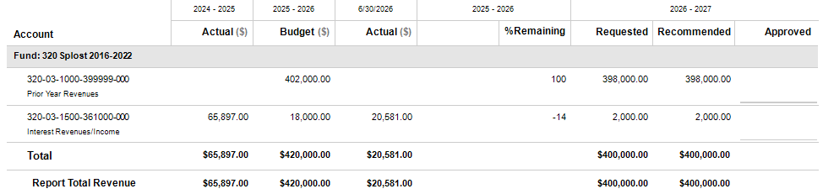

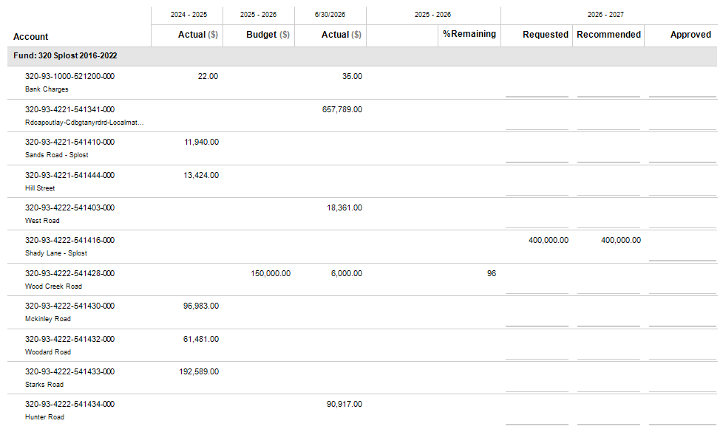
SPLOST-2016 Fund – Detail Expenditures

SPLOST-2016 Fund – Detail Expenditures Continued
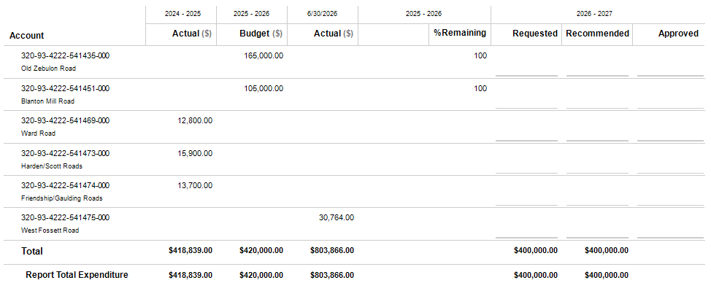

SPLOST-2022 Fund
FUND PROFILE
A referendum was held during May 2022 to determine if the county voters wanted to continue the 1% Special Purpose Local Option Sales Tax (SPLOST) for a six-year period to raise $20,000,000 for capital outlay projects consisting of water, sewer, storm water drainage, road, street and bridge improvements and the payment of principal and interest on indebtedness. During the referendum, 4,985 citizens voted – 2,872 (57.61%) for the SPLOST and 2,113 (42.39%) against. At the time of the referendum, the county had 5,106 registered voters. Therefore, the referendum had a 32.91% voter turn-out rate. Since the referendum was approved, the SPLOST went into effect on October 1, 2022. This Fund is used to account for the SPLOST-2022 proceeds and ensure that these funds are used for the intended purposes.
STAFFING PLAN
Position Title | FY 24-25 | FY 25-26 | FY 26-27
No Positions in this Department | 0 | 0 | 0
Total Positions | 0 | 0 | 0

BUDGET HIGHLIGHTS
- Capital outlay expenditures include the following road paving projects: $2,948,650 for Wood Creek Road, $4,000,000 for Old Zebulon Road, $3,000,000 for Blanton Mill Road.

- Other costs include $702,000 for allocations to the cities for their projects.

- Budgeted $4,600 for Trustee fees and bank charges.

- Other financing uses include $2,344,750 to pay the annual debt payment (principal and interest) for the SPLOST-2022 prefunding bond issuance.

SPLOST-2022 Fund – Detail Revenues
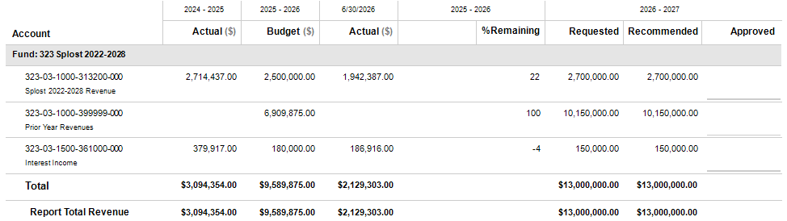

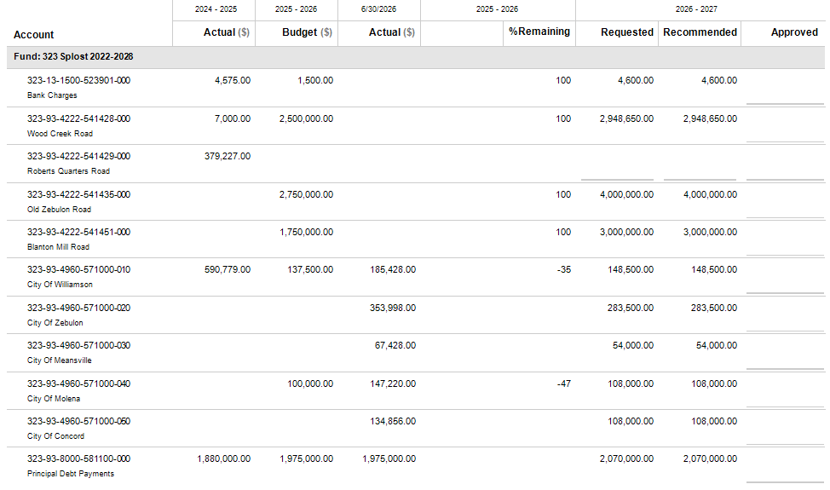
SPLOST-2022 Fund – Detail Expenditures

SPLOST-2022 Fund – Detail Expenditures Continued
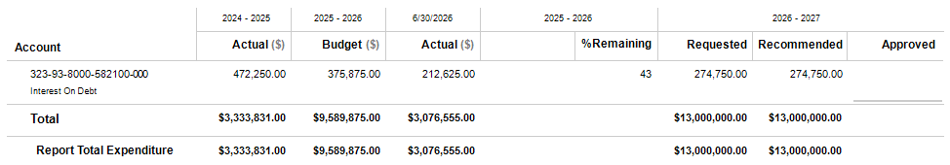

LMIG Fund
FUND PROFILE
LMIG (Local Maintenance and Improvement Grant) and LRA (Local Road Assistance) are funding sources provided by the Georgia Department of Transportation to support local governments in maintaining and improving public road systems. LMIG funds require a local match (30% for Pike County) and are used for activities such as resurfacing, rehabilitation and other eligible roadway improvements. While LRA funds do not require a county match, they are typically more flexible and may be used for routine maintenance and operational needs on local roads. Both funding streams are restricted to transportation related purposes, must be budgeted and tracked separately and are subject to state guidelines and reporting requirements to ensure compliance. Unspent funds generally carry forward for continued use on eligible projects and cannot be diverted to non-transportation expenditures.
STAFFING PLAN
Position Title | FY 24-25 | FY 25-26 | FY 26-27
No Positions in this Department | 0 | 0 | 0
Total Positions | 0 | 0 | 0

BUDGET HIGHLIGHTS
- Capital outlay expenditures include $998,391 to pave Wood Creek Road along with the 30% state required county match of $203,700.

- Other financing uses include $566,309 to pay the annual debt payment (principal and interest) for the GTIB/SRTA loan used in paving 22 roads since August 2023.

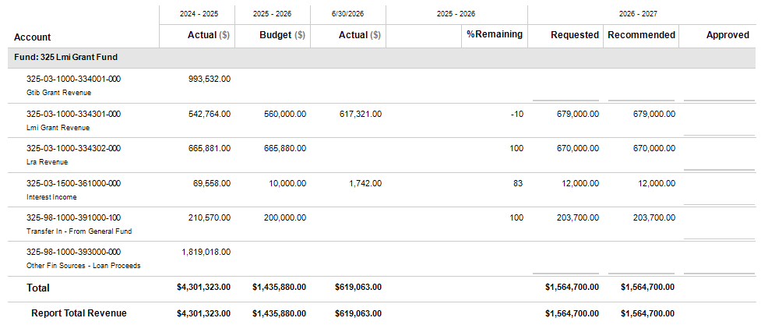
LMIG Fund – Detail Revenues

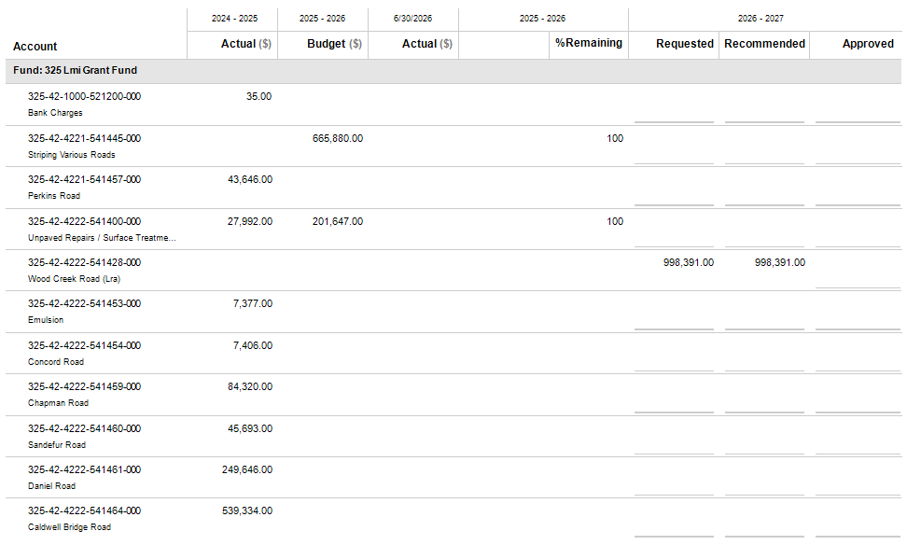
LMIG Fund – Detail Expenditures

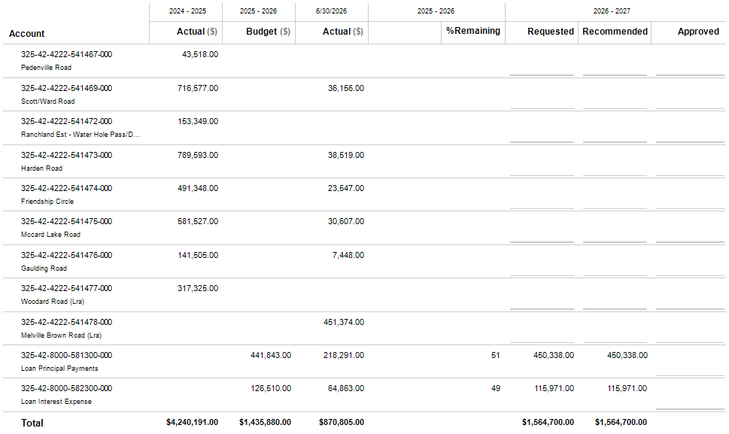
LMIG Fund – Detail Expenditures Continued

LMIG Fund – Detail Expenditures Continued

Capital Improvement Fund
FUND PROFILE
The Capital Improvement Fund was set up to better plan for the acquisition, construction or rehabilitation of capital assets. The goal is to build a five-year forecasting plan that bridges the gap between long-term strategic plans and the annual operating budget.
STAFFING PLAN
Position Title | FY 24-25 | FY 25-26 | FY 26-27
No Positions in this Department | 0 | 0 | 0
Total Positions | 0 | 0 | 0

BUDGET HIGHLIGHTS
- $6,200 budgeted for computers and equipment

- The final of four budgeted county-wide outdoor warning sirens is included for $10,000.

- Capital outlay expenditures include $253,172 for four new Sheriff’s Office vehicles. (3 recurring on an annual basis; 1 to cover new requested deputy positions)

- Capital outlay expenditures also include $92,000 for a new Public Works vehicle

Capital Improvement Fund – Detail Revenues
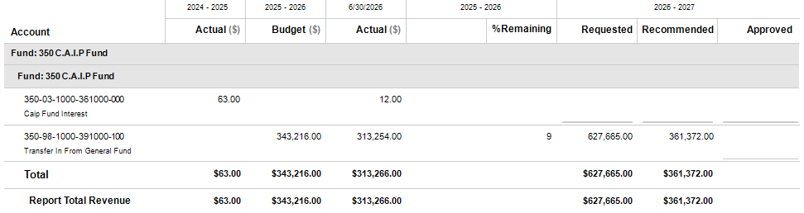

Capital Improvement Fund – Detail Expenditures
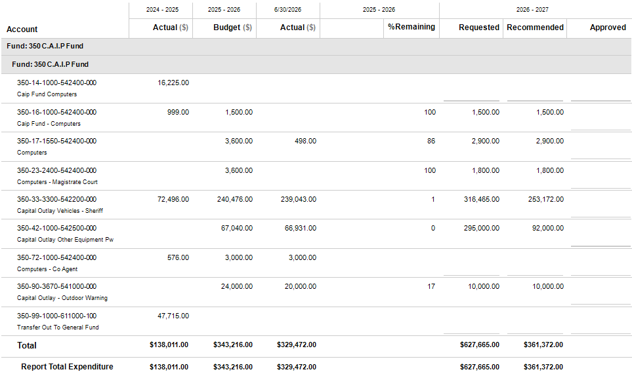

Long Term Debt Schedule

Long Term Debt
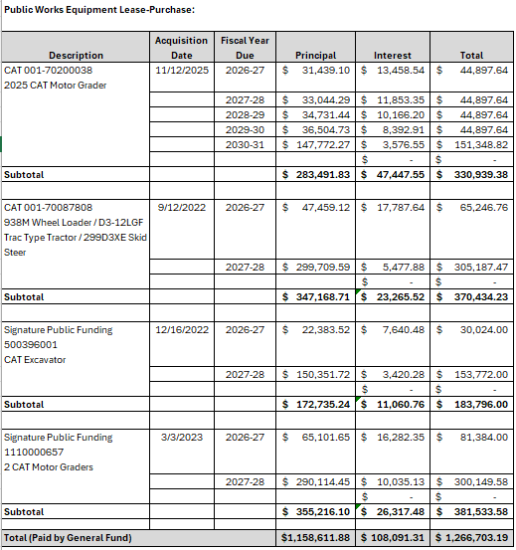
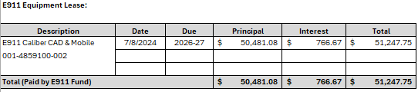

Long Term Debt

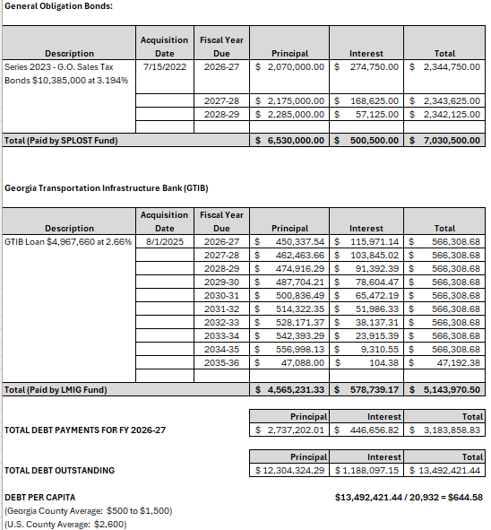

Long Term Debt

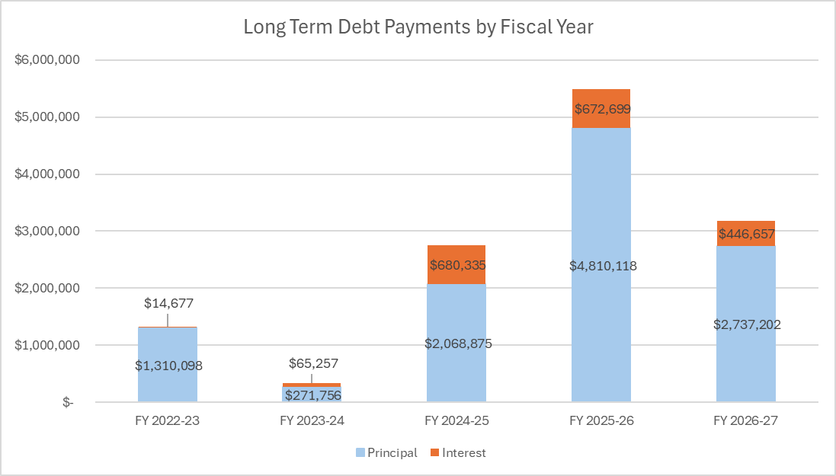

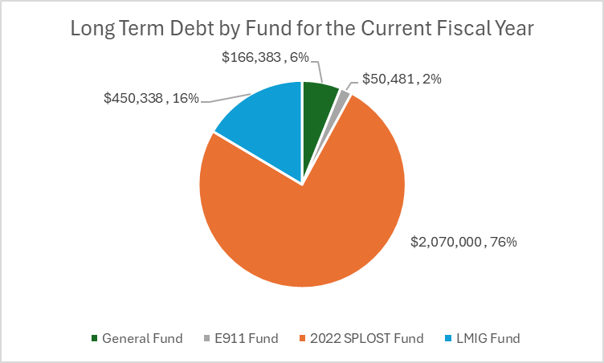
Statistical Information

Statistical Information
Pike County Personnel and Officials Listing
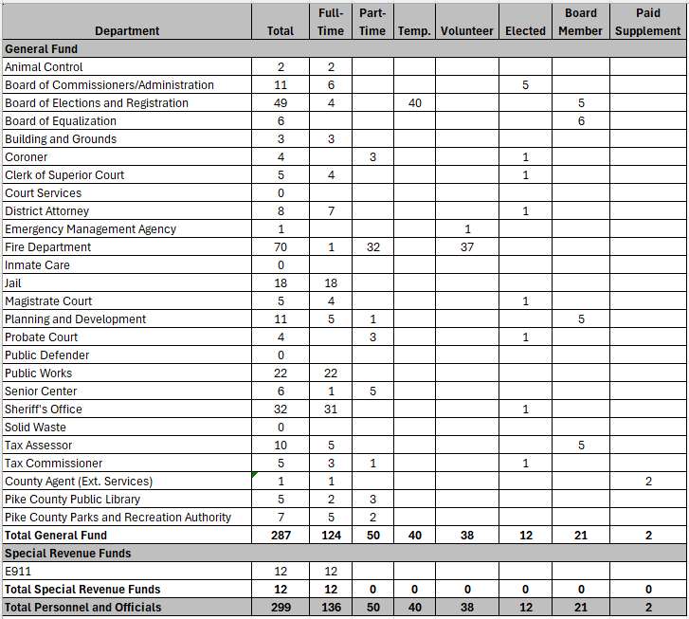

Statistical Information

Year | Population
1970 | 7,316
1980 | 8,937
1990 | 10,224
2000 | 13,688
2010 | 17,869
2020 | 18,888
2025 | 20,932

Statistical Information
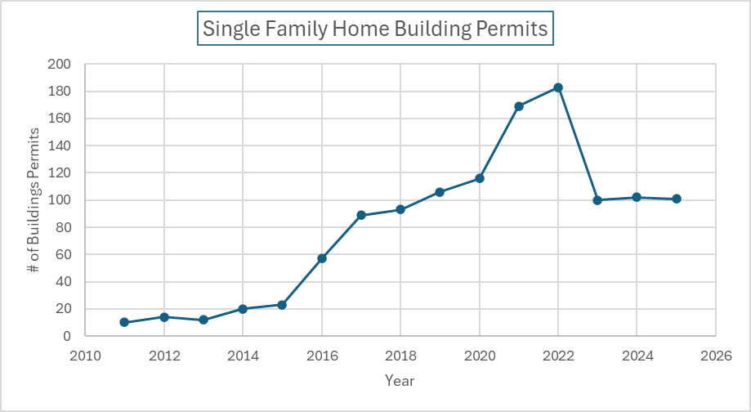

Statistical Information

Statistical Information
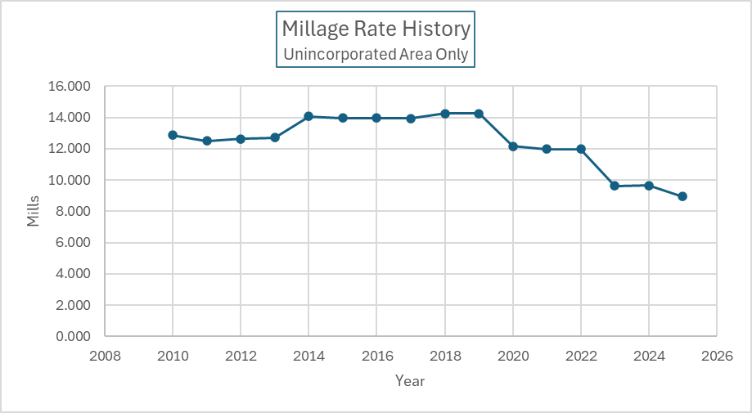

Statistical Information

Statistical Information

Statistical Information

Statistical Information

Statistical Information

Statistical Information
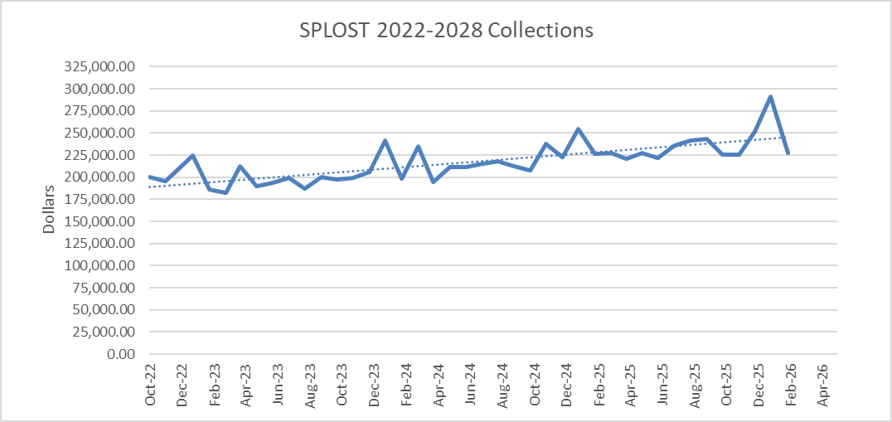

Statistical Information

Pike County Government Officials
Elected Officials
Briar Johnson, Chairman
Tim Daniel, District 1 Commissioner
Tim Guy, District 2 Commissioner
Ken Pullin, District 3 Commissioner
James Jenkins, District 4 Commissioner
Scott Ballard, Superior Court Chief Judge
Rhonda Kreuziger, Superior Court Judge
Ben Miller, Jr., Superior Court Judge
Ben Coker, Superior Court Judge
Matt McCord, Superior Court Judge
Rebekah Hanson, Clerk of Superior Court
Ginny Blakeney, Probate Court Judge
Marcia Callaway-Ingram, Magistrate Court Judge
David Studdard, District Attorney
Jimmy Thomas, Sheriff
Donna Chapman, Tax Commissioner
Terrell Moody, Coroner

Appointed Officials
Rob Morton, County Manager/County Attorney
Angela Blount, County Clerk
David Neyhart, Board of Elections & Registration
Greg Hobbs, Chief Appraiser
Natalie Ashman, Juvenile Court Judge
Stephen Ott, Juvenile Court Judge

Department Directors
Ken Lalumiere, Building & Grounds
Chris Goodman, Public Works
Lavetrece Walker, Senior Citizens Center
Bobby Wilkerson, Fire Department Chief
Jimmy Totten, EMA
Tanya Perkins, Animal Control
(Vacant), Planning & Development

Pike County Board of Commissioners
331 Thomaston Street / P.O. Box 377
Zebulon, Georgia 30295-0377
(770) 567-3406

www.pikecoga.gov

