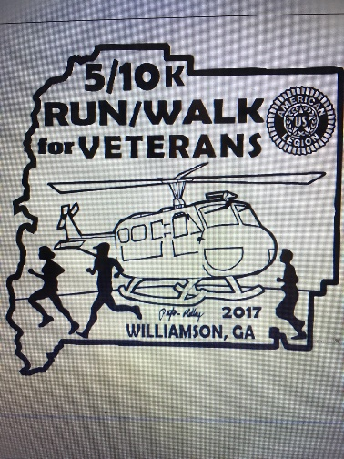Williamson
5K/10K Walk/Run
For Veterans
Saturday, August 26, 2017
W/R start window: 7:30 a.m. – 12:00 p.m.

Event Location: Benson Hilly Park Pavilion (City of Williamson Fitness Park), Zebulon Rd, Williamson, GA.
Course Description: 5K and 10K routes are generally flat. There are paved roads, mowed grass pathways, and trails; and some small hills.
Souvenir: Every registered participant gets a T-shirt. Design pictured upper right corner of form.
Proceeds: Benefits the Veterans and Pike County American Legion Post 197.
Entry Cost information: Early pre-registration: $25 prior to 19 August 2017. Late registration: $35 after 19 August, 2017 and day of event. All who register will get a T-shirt and free event snacks and beverages. Guaranteed T-shirts to all registered participants. Those who registered, but could not attend, T-shirts will be mailed.
Make checks payable to: Pike County American Legion Post 197 and mail with below Registration Form to: Event Director, ATTN: Bryan Richardson, 1067 Strickland Road, Concord, GA 30206.
Questions: Contact Post 197 email: pikepost197@gmail.com
No refunds will be issued for any reason

-----------------------detach here -----------------------

26 August 2017 Williamson 5K/10K Run/Walk for Veterans
REGISTRATION FORM
PLEASE PRINT LEGIBLY

Name:_______________________________________________________________
Address:_____________________________________________________________
City, State, Zipcode ____________________________________________________
Phone:_____________________________E-mail:____________________________
SHIRT SIZE (circle One): S M L XL XXL XXXL
Waiver (MUST BE SIGNED)
In consideration of your accepting this entry, I, the below signed, intending to be legally bound, for myself, my heirs, my executors and administrators, waive and release and any all rights and claims for damages I may have against the race, and sponsors and their representatives, successors and assigns for any and all injuries suffered by me in said event. I attest that I will participate in this event as a fitness event, that I am physically fit and sufficiently trained for the distance of this event. Furthermore, I hereby grant full permission to use my name and likeliness, as well as any photographs and any record of this event in which I may appear for any legitimate purpose, including advertising and promotion.
Signature_________________________________________Date______________
Parent or Guardian if under 18__________________________________________

