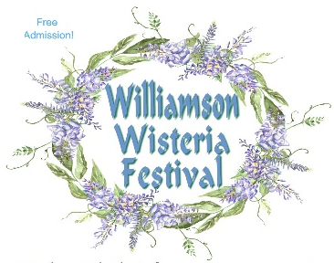

Williamson Wisteria Festival
5K/10K Fun Run/Walk Fundraiser
Bicentennial Event
Saturday, 2 April 2022

Event Location: Benson Hilley Park (City of Williamson Fitness Park), Zebulon Rd, Williamson, GA.
R/W start window: 7:30 -10:00 a.m.
Course Description: 5K and 10K routes are generally flat. There are paved roads, mowed grass pathways, and trails; and some small hills.
Souvenir: Every registered participant gets a T-shirt.
Proceeds: Benefits the Pike County American Legion Post 197 Veteran and Community Programs
Entry Cost information: Early pre-registration: $25 with T-shirt. Late registration: $35 after 26 March 2022 and day of event. All who register will get a T-shirt and event snacks and beverages. Those who registered, but could not attend, T-shirt will be delivered. Extra T-shirt: $10.
Honor a deceased Veteran with his/her name on back of T-shirt with donation/sponsorship of $50.
Make checks payable to: Pike County American Legion Post 197 and mail with below Registration Form to: American Legion Post 197, ATTN: Event Director Bryan Richardson, P.O. Box 781, Zebulon 30295
Questions: Contact Event Director at email: rich5060@bellsouth.net
No refunds will be issued for any reason

-----------------------detach here -----------------------

5K/10K Fun Run/Walk REGISTRATION FORM 2 April 2022
PLEASE PRINT LEGIBLY

Name:_______________________________________________________________
Address:_____________________________________________________________
City, State, Zipcode ____________________________________________________
Phone:_____________________________E-mail:____________________________
SHIRT SIZE (circle One): Y-Size____ S M L XL XXL XXXL
Deceased Veteran’s name to be honored ($50 Donation/Sponsorship): ________________________
Waiver (MUST BE SIGNED)
In consideration of your accepting this entry, I, the below signed, intending to be legally bound, for myself, my heirs, my executors and administrators, waive and release and any all rights and claims for damages I may have against the race, and sponsors and their representatives, successors and assigns for any and all injuries suffered by me in said event. I attest that I will participate in this event as a fitness event, that I am physically fit and sufficiently trained for the distance of this event. Furthermore, I hereby grant full permission to use my name and likeliness, as well as any photographs and any record of this event in which I may appear for any legitimate purpose, including advertising and promotion.
Signature_________________________________________Date______________
Parent or Guardian if under 18__________________________________________

